**ONLINE SHOPPING SYSTEM PROJECT**

**Submitted in partial fulfilment for the award of**

**MASTER OF COMPUTER APPLICATIONS DEGREE**



**Session 2023-2024**

**By**

**BAL KRISHNA OJHA**

**(2200110140037)**

**Under the guidance of**

**DR. MANMOHAN MISHRA**

**UNITED INSTITUTE OF MANAGEMENT-011**

**AFFILIATED TO**

**Dr. A.P.J. Abdul Kalam Technical University (APJAKTU), LUCKNOW**

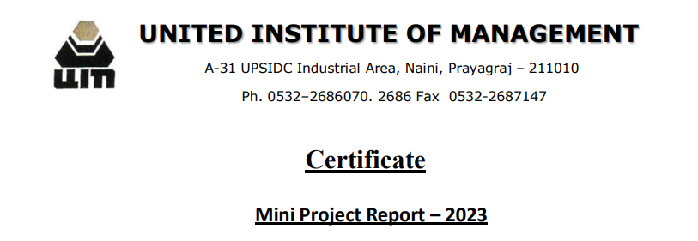

This is to certify that the Project titled “**ONLINE SHOPPING SYSTEM**” is a bonafide record of independent work done by **BAL KRISHNA OJHA (Roll No: 2200110140037)** under my supervision during **21st Aug to 30th Sept 2023,** submitted to the Department of Computer Applications, **UNITED INSTITUTE OF MANAGEMENT, NAINI, PRAYAGRAJ** in partial fulfilment for the award of the degree of **MASTER IN COMPUTER APPLICATION from Dr. A.P.J. Abdul Kalam Technical University (APJAKTU), LUCKNOW.**

The project is original work of the student and has not been submitted anywhere else in any manner.

Date: (**DR. MANMOHAN MISHRA**)

Associate Professor

Department of Computer Application

**Counter Signed**

Signature…………………………….

**(Prof. K.K. Malviya)**

**Principal**

Date……………………………………



|  |
| --- |
| Index |

|  |  |  |
| --- | --- | --- |
| **Sr. No.** | **Description** | **Page No.** |
| **1** | Introduction | **06-07** |
| **2** | ProblemIdentification | **08** |
| **3** | Objective | **09** |
| **4** | System Study | **10** |
| **5** | System Analysis | **11** |
| **6** | Feasibility Study   * Operational Feasibility * Technical Feasibility * Economical Feasibility | **12-13** |
| **7** | Software Engineering | **14** |
| **8** | Requirements   * External Interface * Software Interface * Hardware Interface * Communication Interface | **15** |
| **9** | Analysis (Data Flow Diagram) | **16** |
| **11** | System Design | **17-28** |
| **12** | Coding | **29-86** |
| **13** | Implementation & Maintenance | **87** |
| **14** | Testing | **88-89** |
| **15** | Future Scope | **90** |
| **16** | Bibliography/References | **91** |

**ACKNOWLEDGEMENT**

I am very grateful to **Dr. K.K. Malviya (Principal)** and **Dr. Awaneesh Gupta (Head of Department)**, United Institute of Management for providing me the department facility during the course of this project.

I am grateful to my project guide **Dr. Manmohan Mishra** for giving his valuable time and constructive guidance in preparing the Synopsis/Project.

It would not have been possible to complete this project in short period of time without his kind encouragement and valuable guidance.

I am highly indebted to our project coordinator **Mr. Dhananjay Kumar Singh (Assistant Professor)**, Department of Computer Application for their guidance and constant supervision as well as for providing necessary information regarding the project. He was like a great mentor during the whole project.

I would also like to express our special thanks to our friends and all staff members of the “Department of Computer Application” for encouraging me and giving such attention and time during this project.

Date: **Signature**

**(Bal Krishna Ojha)**

**CERTIFICATE OF ORIGINALITY**

I hereby declare that the Project entitled “**ONLINE SHOPPING SYSTEM**” submitted to the Department of Computer Application, **UNITED INSTITUTE OF MANAGEMENT, NAINI, PRAYAGRAJ** in partial fulfilment for the award of the Degree of **MASTER IN COMPUTER APPLICATION** during session 2022-2023 is an authentic record of my own work carried out under the guidance of Dr. **Manmohan Mishra** and that the project has not previously formed the basis for the award of any other degree.

This is to certify that the above statement made by me is correct to the best of my knowledge.

Place: Prayagraj Signature of the candidate:

Date:  **Bal Krishna Ojha**

**(2200110140037)**

**INTRODUCTION**

This project is a web based shopping system for an existing shop. Online shopping (sometimes know as e-tail from “electronic retail” or e-shopping) is a form of electronic commerce which allows consumers to directly buy goods or services from a seller over the internet using a web browser. Alternative names are: e-web-store, e-shop, e-store, Internet shop, web-shop, web-store, online store, online

storefront and virtual store.

Mobile commerce (or m-commerce) describes purchasing from an online retailer’s mobile optimized online site or app.

An online shop evokes the physical analogy of buying products or services at a bricks-and-mortar retailer or shopping center; the process is called business-to-consumer (B2C) online shopping. In the case where a business buys from another business, the process is called business-to-business (B2B) online shopping. The largest of these online retailing corporations are Alibaba, Amazon.com, and eBay.

* Online shopping is the process of buying goods or services over the internet.
* It is a convenient and efficient way to shop, as it allows consumers to browse and purchase products from the comfort of their own homes.
* The first online shopping transaction took place in 1994, when a man named Michael Aldrich purchased a Sting CD from a retailer in the UK.

**There are many reasons why online shopping has become so popular.**

* One reason is convenience. Online shoppers can shop at any time of day or night, from anywhere in the world.
* Another reason for the popularity of online shopping is the wider selection of products available.

**Of course, there are also some risks associated with online shopping.**

* One risk is that shoppers may not be able to see or touch the products they are buying before they purchase them.
* Another risk is that shoppers may not be able to return or exchange products that they are not happy with.

**Overall, online shopping is a safe and convenient way to shop.**

**However, it is important to be aware of the risks and to take steps to protect yourself**

**PROBLEM IDENTIFICATION**

There are many problems that can be identified in online shopping.

**Some of the most common problems include:**

* **Product quality:** Customers are often concerned about the quality of products they buy online. They may worry that the products are counterfeit or that they will not be as good as they appear in the photos.
* **Shipping and delivery:** Customers may be unhappy with the shipping and delivery time of their online orders. They may also beunhappy with the cost of shipping.
* **Payment security:** Customers are concerned about the security of their financial information when they shop online. They want to be sure that their credit card numbers and other personal information are safe.
* **Return policy:** Customers want to be sure that they can return or exchange products they buy online if they are not satisfied. They want to be sure that the return policy is easy to understand and that they will not be charged any fees for returning or exchanging products.
* **Customer service:** Customers want to be able to get help if they have any problems with their online orders. They want to be sure that customer service is responsive and helpful.
* **Website design and usability:** Customers want to be able to easily find the products they are looking for and to checkout quickly and easily. They want the website to be easy to use and navigate.
* **Fraud and scams:** Customers are concerned about the risk of fraud and scams when they shop online. They want to be sure that the website they are shopping on is legitimate and that their personal information is safe.

**OBJECTIVE**

The objective of **online shopping** is to provide customers with a convenient and efficient way to purchase products or services.Onlinestores offer a wide variety of products and services, and customers can browse and shop at their own pace. They can also

compare prices and read reviews before making a purchase.

**Here are some of the specific objectives of online shopping:**

* To provide a more convenient shopping experience, as customers can shop from home or anywhere else with an internet connection.
* To provide a more efficient shopping experience, as customers can browse and compare products and prices quickly and easily.
* To provide a more personalized shopping experience, as customers can create wish lists and receive recommendations based on their past purchases.
* To provide a more secure shopping experience, as customers can pay for their purchases with a credit card or other secure payment method.

Online shopping has become increasingly popular in recent years, and it is expected to continue to grow in the future. This is due to the convenience, efficiency, and personalization that online shopping offers.

**SYSTEM STUDY**

Information systems projects’ originate from many reasons: to achieve greater speed in processing data, better accuracy and improved consistency, faster information retrieval, integration of business areas, reduced cost and better security. The sources also vary project proposals originate with department managers, senior executives and systems analysis.

Sometimes the real origin is an outside source, such as a government agency which stipulates systems requirements the organization must meet. When the request is made, the first systems activity, the preliminary investigation, begins. The activity has three parts: request clarification, feasibility study and request approval.

**Existing System:**

The existing system was an automated system. But it was found to be inefficient in meeting the growing demands of population.

**Drawbacks in the existing systems:**

Disadvantage of the existing system:

* Time Consuming
* Expensive
* Needed an agent
* We have to out for that

**SYSTEM ANALYSIS**

System analysis is the process of gathering and interpreting facts, diagnosing problems and using the information to recommend improvements on the system. System analysis is a problem solving activity that requires intensive communication between the system users and system developers.

System analysis or study is an important phase of any system development process.

**Here are some of the key aspects to consider when analyzing an online shopping project:**

* **Market size and growth potential:**The size and growth potential of the market for the products or services being sold online is an important factor to consider. A large and growing market indicates that there is a strong demand for the products or services, which can make the online shopping project more successful.
* **Competition:** The level of competition in the online marketplace is another important factor to consider. A high level of competition can make it more difficult for an online shopping project to succeed, but it can also be a sign that there is a large and growing market for the products or services being sold.
* **Customer demographics:** The demographics of the target customers are also important to consider. The age, gender, income level, and location of the target customers can help to determine the best marketing strategies for the online shopping project.
* **Technology requirements:** The technology requirements for the online shopping project need to be carefully considered. The project needs to have a secure and reliable website or mobile app that can handle the volume of traffic expected.
* **Customer service:** Excellent customer service is essential for any online shopping project. Customers need to be able to easily contact the customer service team with questions or problems.

**Feasibility Study**

All projects are feasible when given unlimited resources and infinite time. It is both necessary and prudent to evaluate the feasibility of a project at the earliest possible time. A feasible study is not warranted for system in which economic justification is observed, technical risk is low, few legal problems are expected and no reasonable alternative exist.

An estimate is made of whether the identified user needs may be satisfied using our recent software and hardware technologies. The study will decide if the proposed system will be cost effective, from the business point of view an it can be developed in the existing budgetary constraints. The feasibility study should be relatively sharp ad quick. The gesture should inform the decision of whether to go ahead with a more detailed analysis.

Feasibility study may be documented as a separated report to higher officials of the top-level management and can be included as appendices to the system specification. Feasibility of producing the quality software is reduced. The study is done in three phases:

1. **Operational Feasibility**

Proposed projects are beneficial only if they can be turned into information systems that will meet the organizations operating requirements.

The purpose of the operational feasibility study is to determine whether the new system will be used if it is developed and installed. And whether there will be resistance from users that will determine the possible application benefit.

In the proposed System named **Online Webstore** the

operational feasibility study is performed with the help of the users of the system and the management.

1. **Technical Feasibility**

The technical feasibility study is a study of function, performances and constraints and the ability to create an

acceptable system. Technical feasibility is frequently the most difficult area to achieve at the stage of product engineering process. Considering that are normally associated with the technical feasibility include.

* + - Development risk
    - Resource availability
    - Technology

1. **Economical Feasibility**

A cost evaluation is weighted against ultimate income or benefit derived from the developed system or product.

The economical feasibility of the Online Webstore is checked and accepted by both the users and the

management of the organization. Since the Online Webstore has to deals with sensitive data like the software codes of organization the economical feasibility proved that it is economical and it can help the organization to avoid financial disaster due to the lose of data.

**SOFTWARE ENGINEERING**

Software engineering is the process of designing, developing, testing, and maintaining software.

E-Commerce Software Engineers are involved in the meat of our development project, tackling projects that will involve the core development of some of our main systems and modules.

While all the stuff that you see on the website may look easy, it can clients satisfied.

E-Commerce Software Engineers are part of the core team with responsibilities encompassing product-building and world-class delivery systems.

**Responsibilities:**

* The E-Commerce Software Engineer should be willing to tackle any technology language, or development environment on an as-needed basis.
* Complete high-impact projects using object-oriented code in modern frameworks and architecture.

**Requirements:**

* Incredible coding skills and superhuman programming capacity, as demonstrated by a continuous string of successful projects.
* E-Commerce Software Engineers should have in-depth mastery of multiple technologies, languages, and development environments.
* Excellent command of written and spoken English
* May involve after-hours works or on-call situations.

**REQUIREMENTS**

**External Interface Requirements:**

**User Interface:** User of the system will be provided with the Graphical user interface, there is no command line interface for any functions of the product. The user will get a pages i.e. Login page followed by Password

**Software Interface:**

1. **Operating System:** Windows 10
2. **User Interface:** GUI
3. **Integrated Development Environment (IDE):** Visual Studio Code
4. **Web Technology Used:** HTML, CSS, JAVASCRIPT

**Hardware Interface:**

1. **Processor:** Intel Processor / Ryzen Processor
2. **RAM:** Minimum of 4GB RAM
3. **Graphics Card:** Not Mandatory
4. **Display Resolution:** 1024x768 (For Better Experience in Desktop/Laptop)

**Communication Interface:**

The two parties should be connected through either by LAN or WAN for the communication.

RECEIVER

SENDER

**Sensssdfssff**

Communication channels

**ANALYSIS (DATA FLOW DIAGRAM)**

Request for Login

Request for Registration

USER

ADMIN

Response

Response

**DFD 0-LEVEL**

LOGIN PAGE

ABOUT US PAGE

HOME PAGE

CONTACT PAGE

SHOP PAGE

E-CART PAGE

BLOG PAGE

**DFD 1-LEVEL**

**SYSTEM DESIGN**

**Home Page (Design 1)**

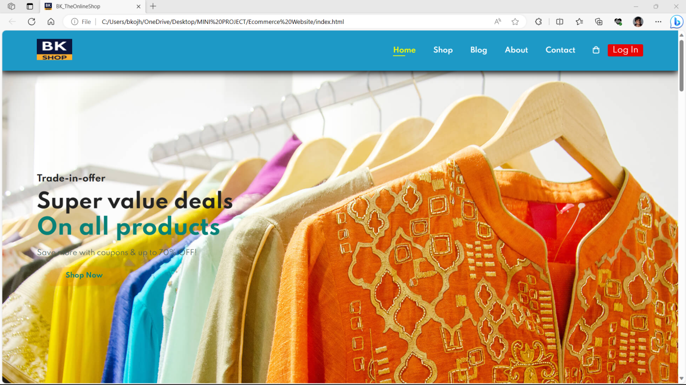

**Home Page (Design 2)**

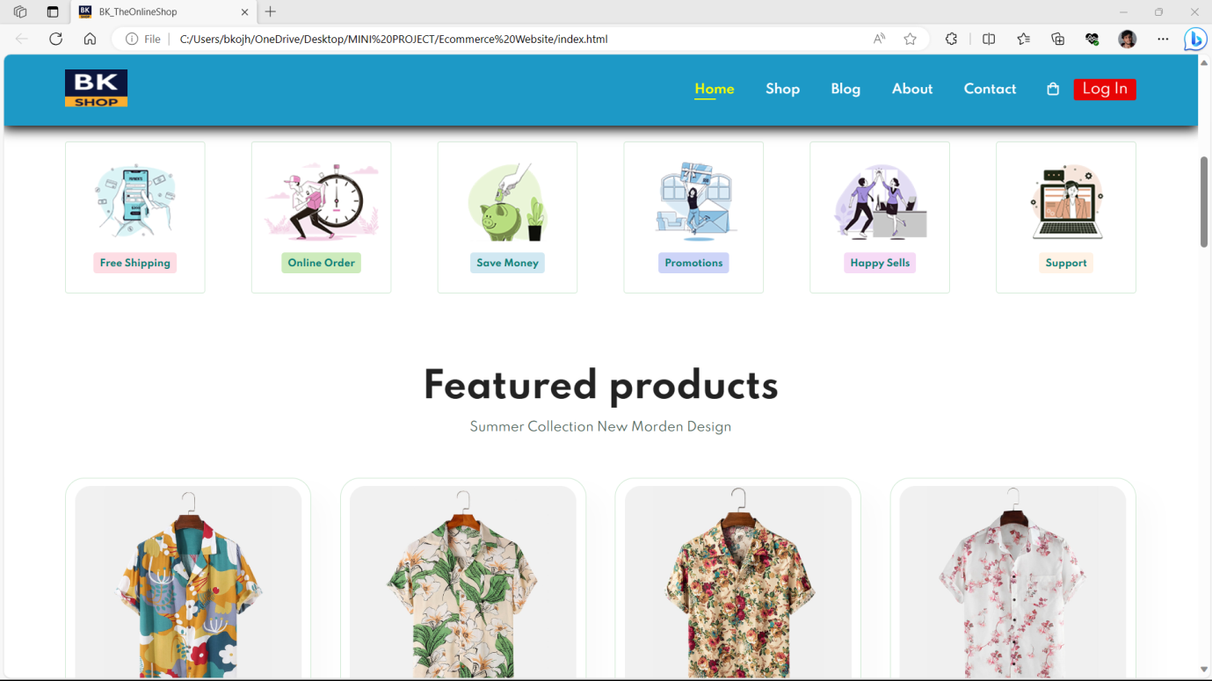

**Home Page (Design 3)**

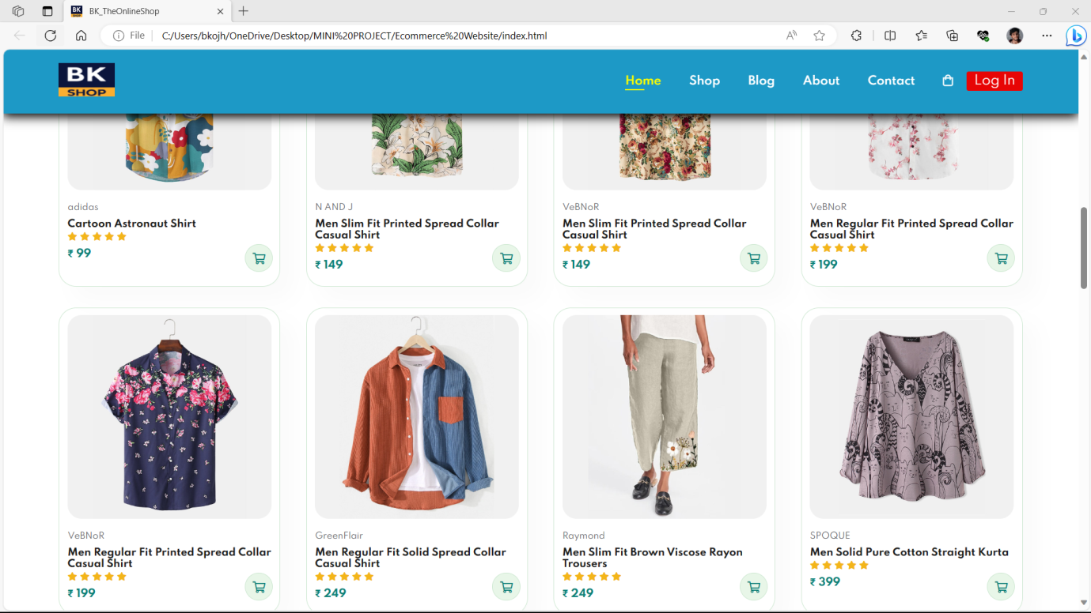

**Home Page (Design 4)**

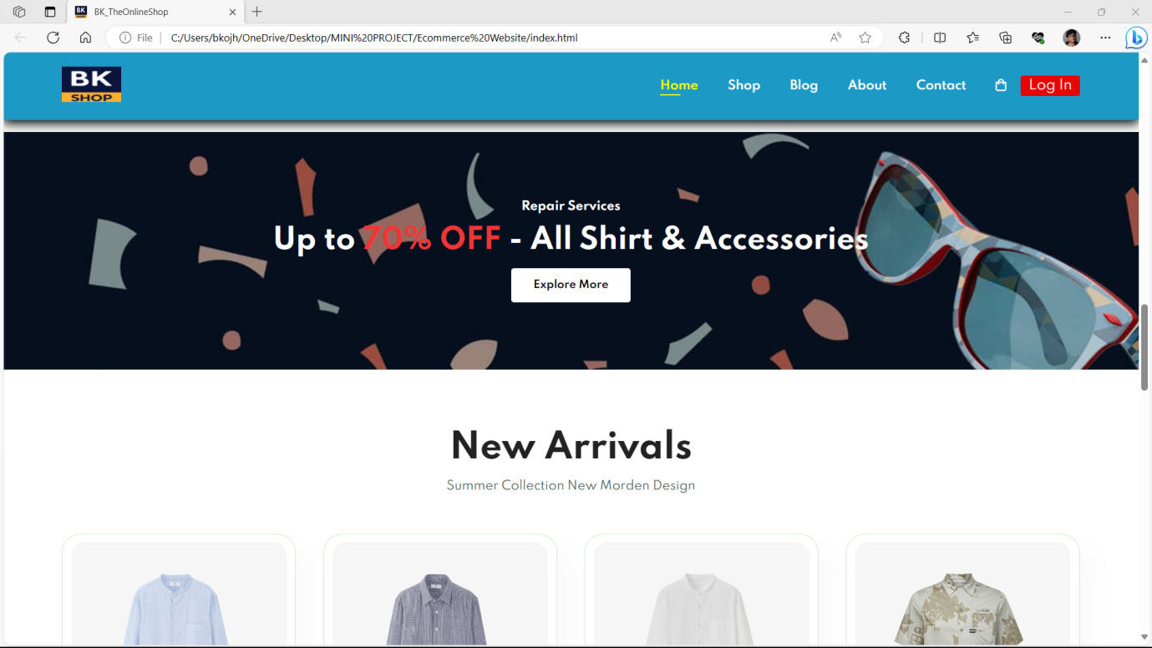

**Home Page (Design 5)**

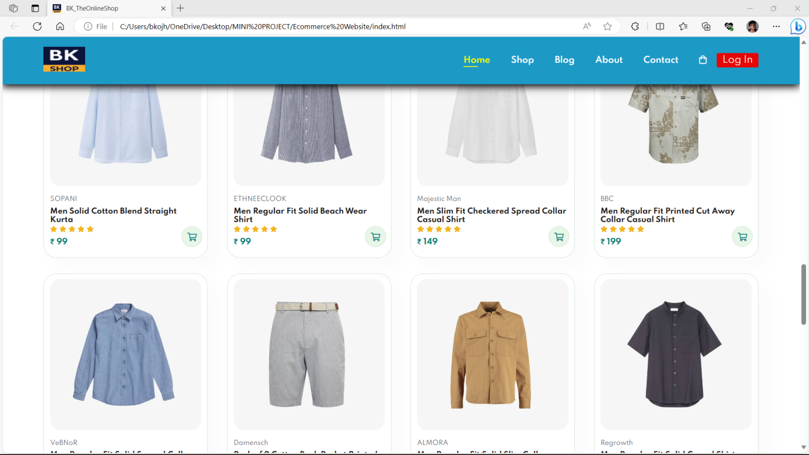

**Home Page (Design 6)**

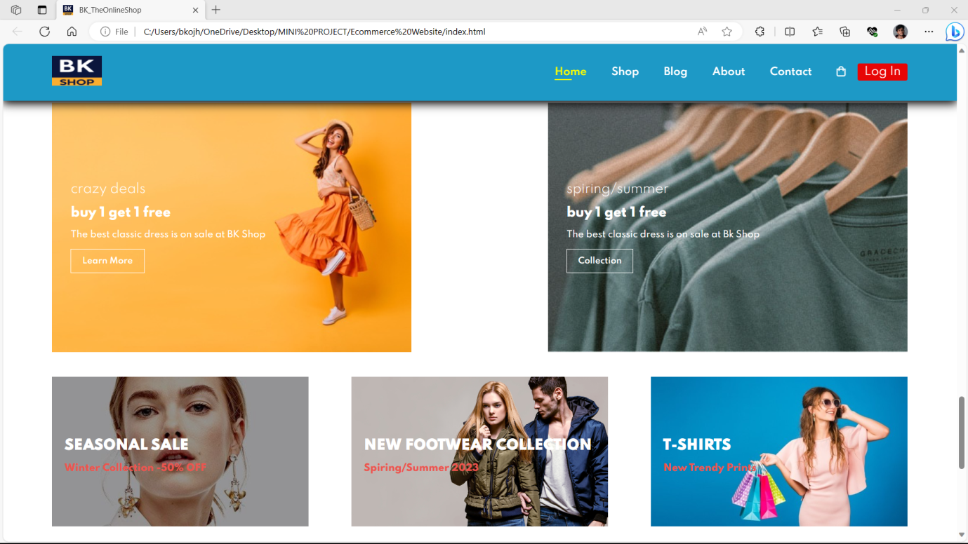

**Home Page (Design 7)**

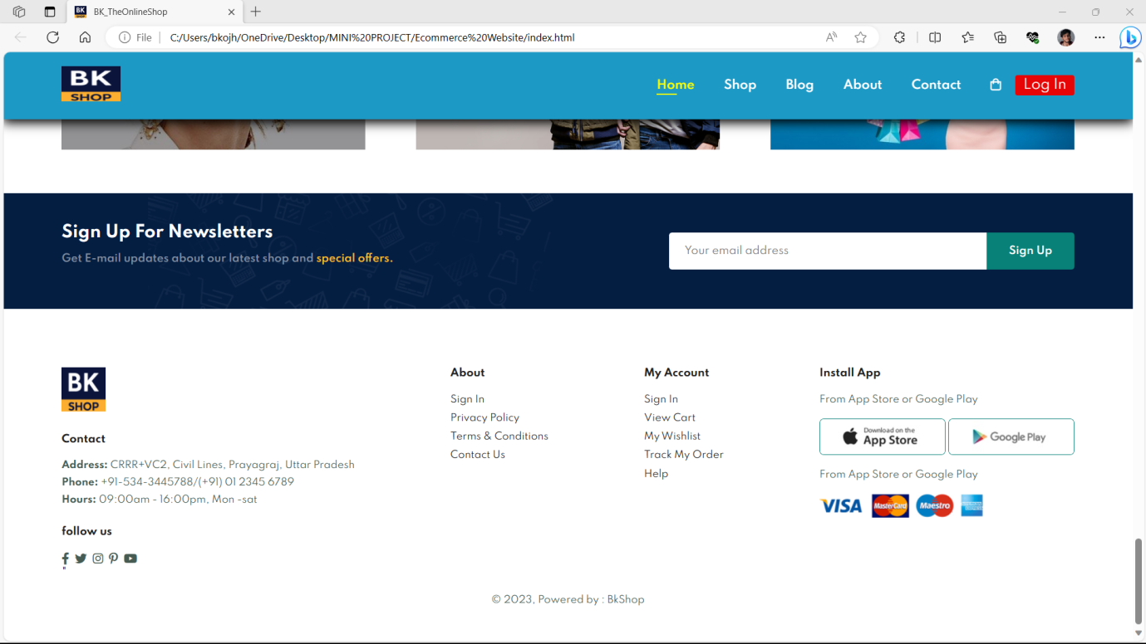

**Shop Page (Design 1)**

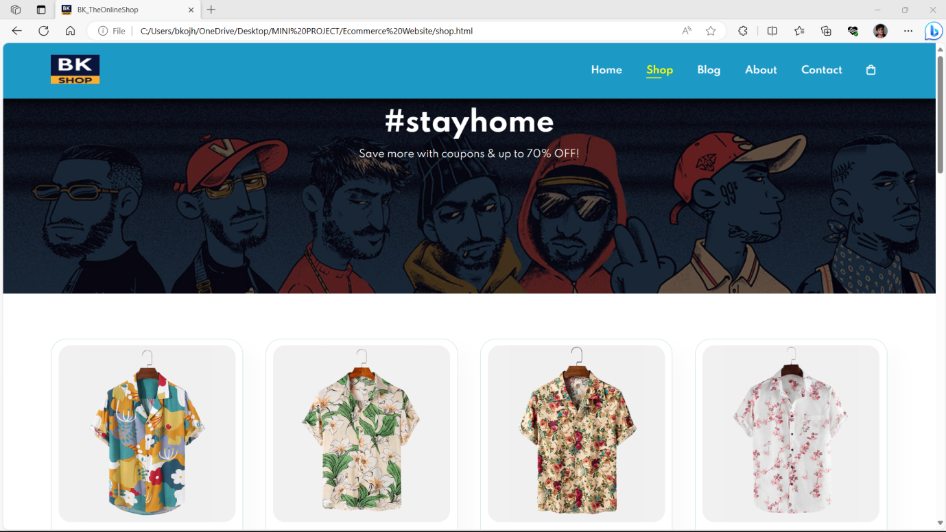

**Shop Page (Design 2)**

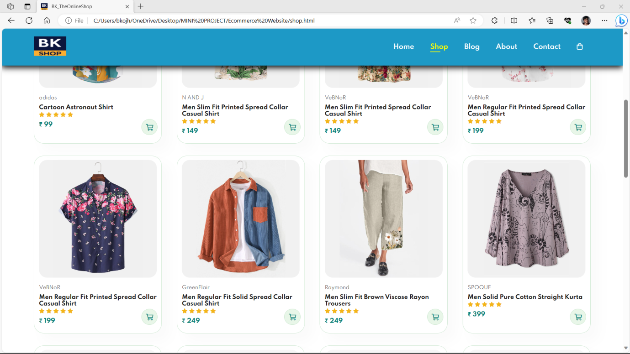

**Shop Page (Design 3)**

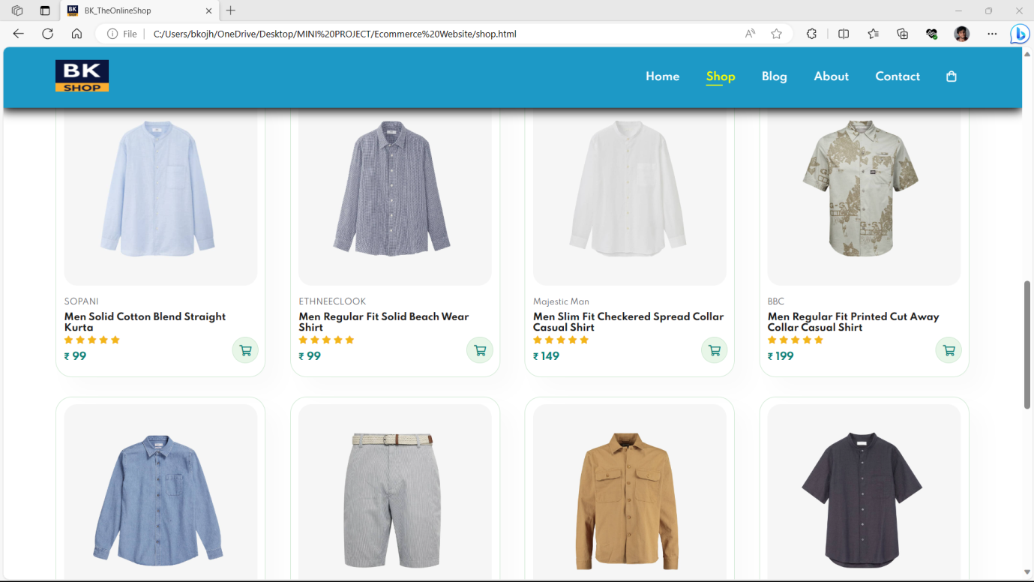

**Single Product Page (Design 1)**

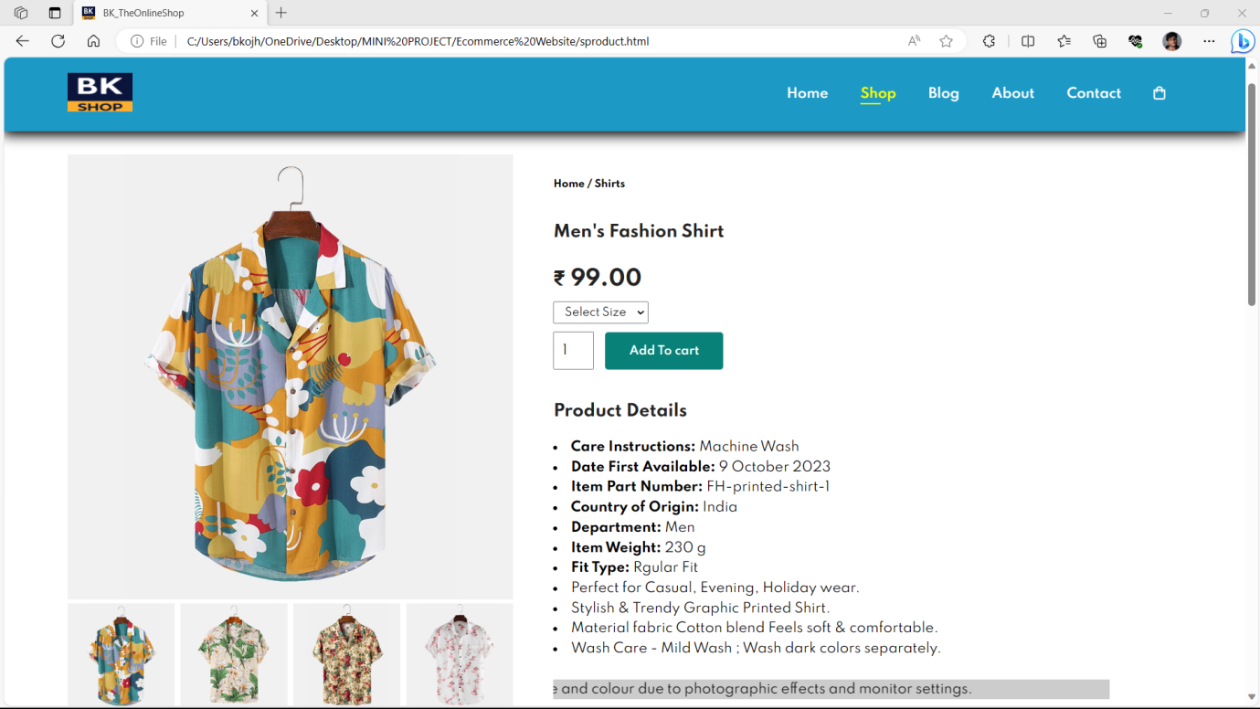

**Single Product Page (Design 2)**

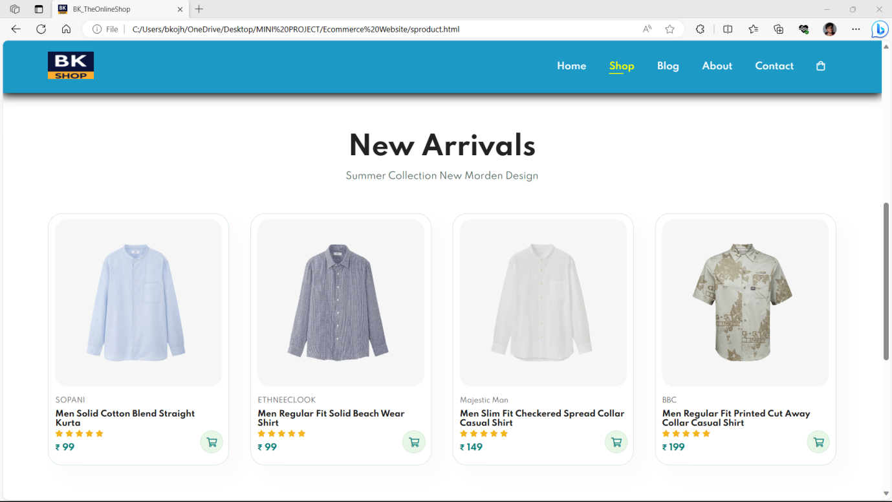

**Blog Page (Design 1)**

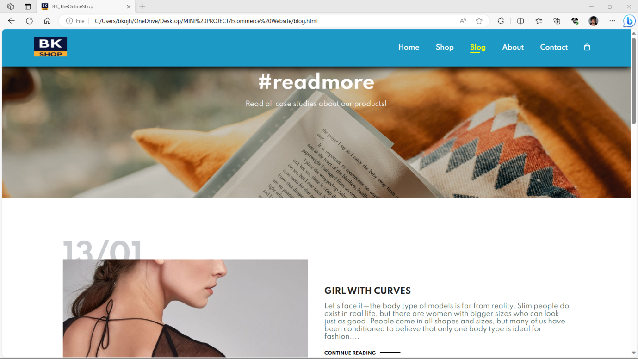

**Blog Page (Design 2)**

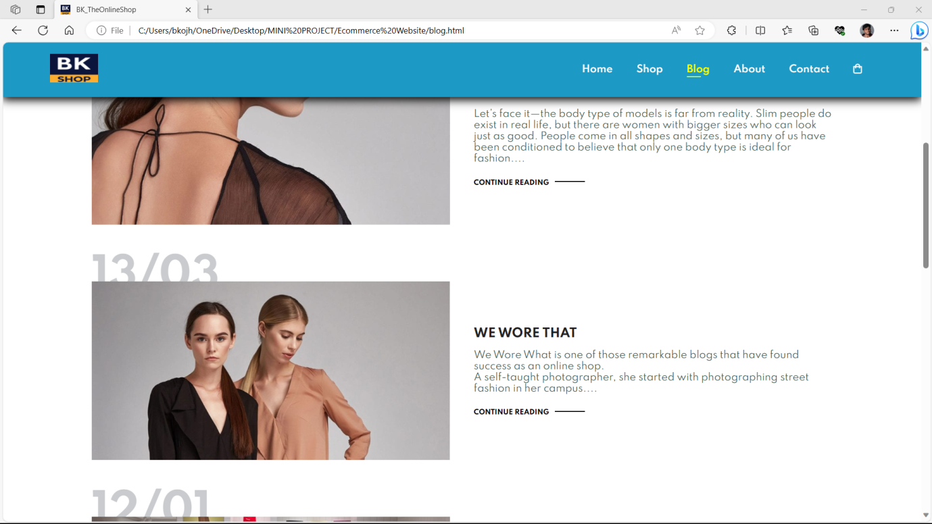

**Blog Page (Design 3)**

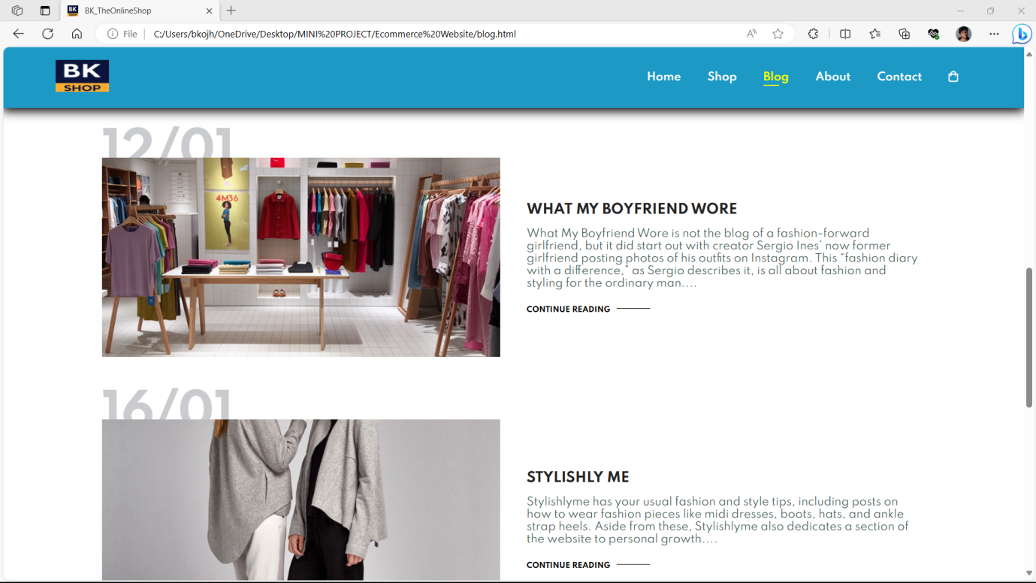

**About Us Page (Design 1)**

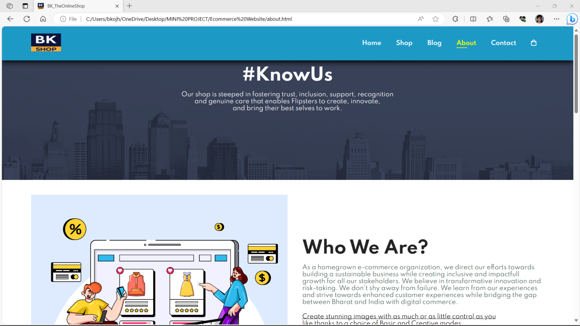

**About Us Page (Design 2)**

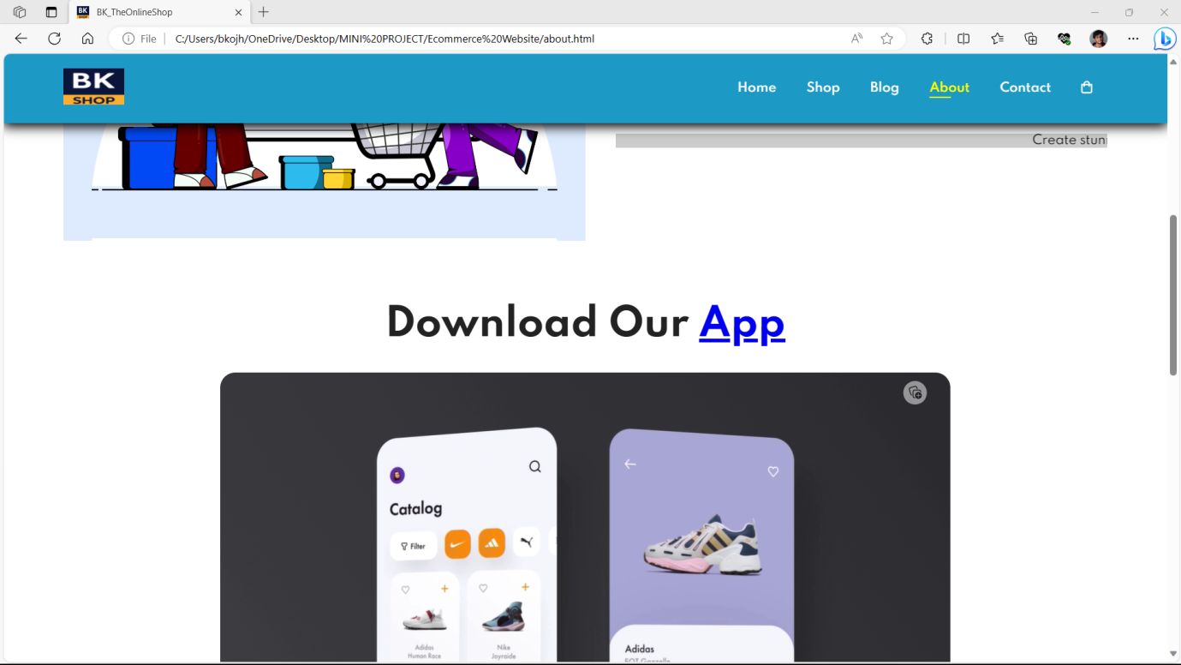

**About Us Page (Design 3)**

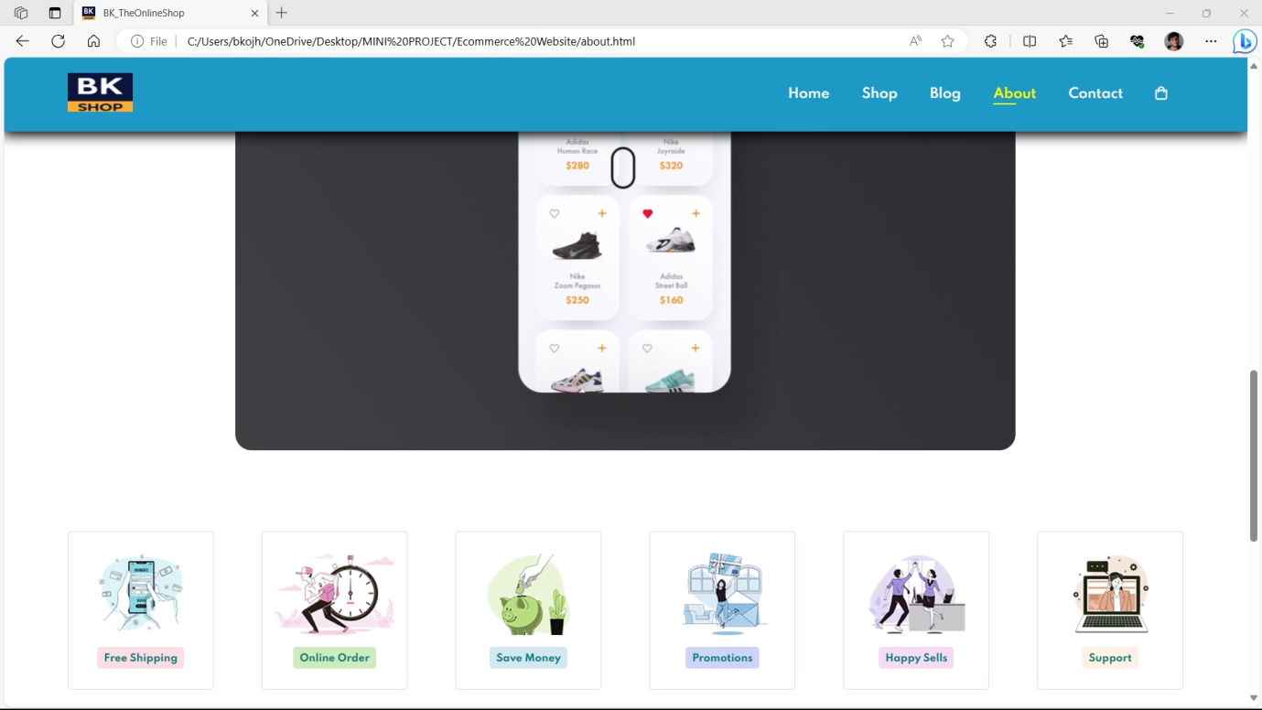

**Contact Page (Design 1)**

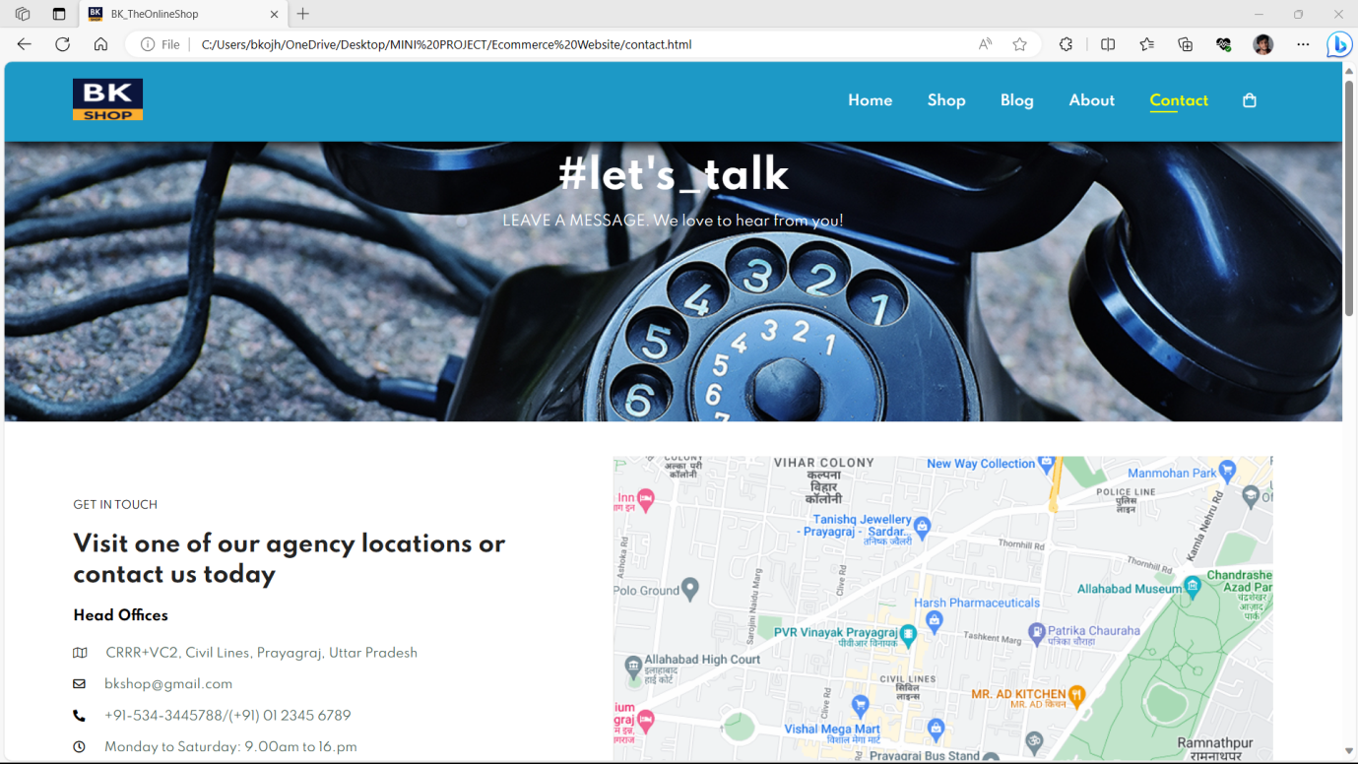

**Contact Page (Design 2)**

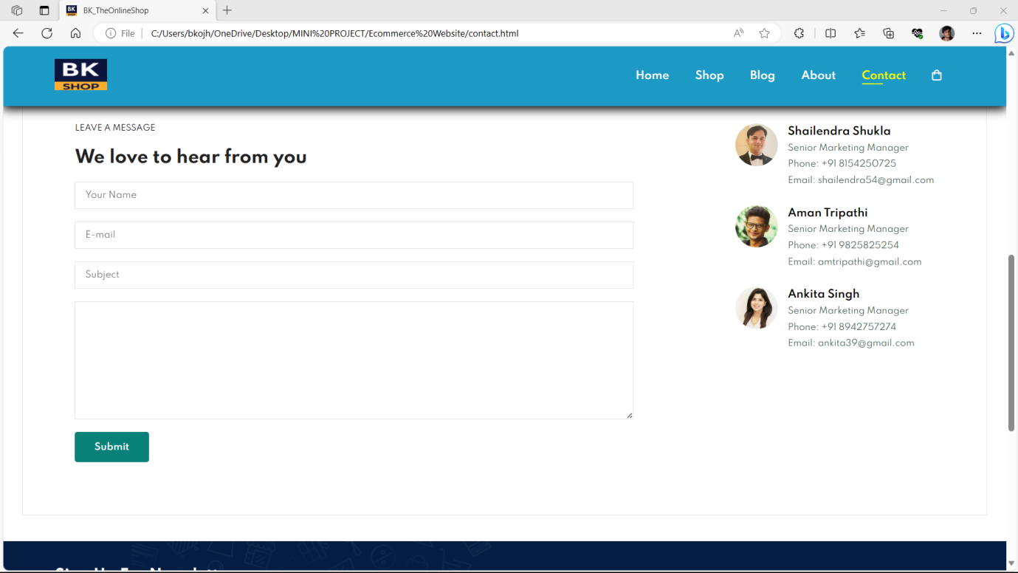

**Cart Page (Design 1)**

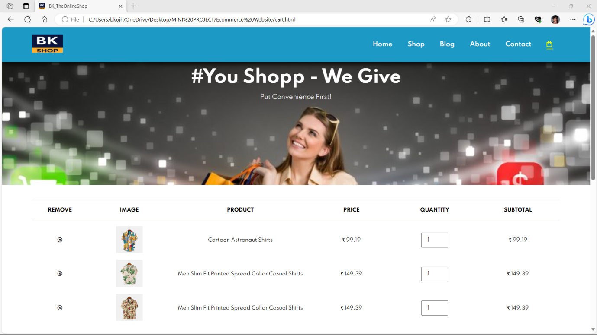

**Cart Page (Design 2)**

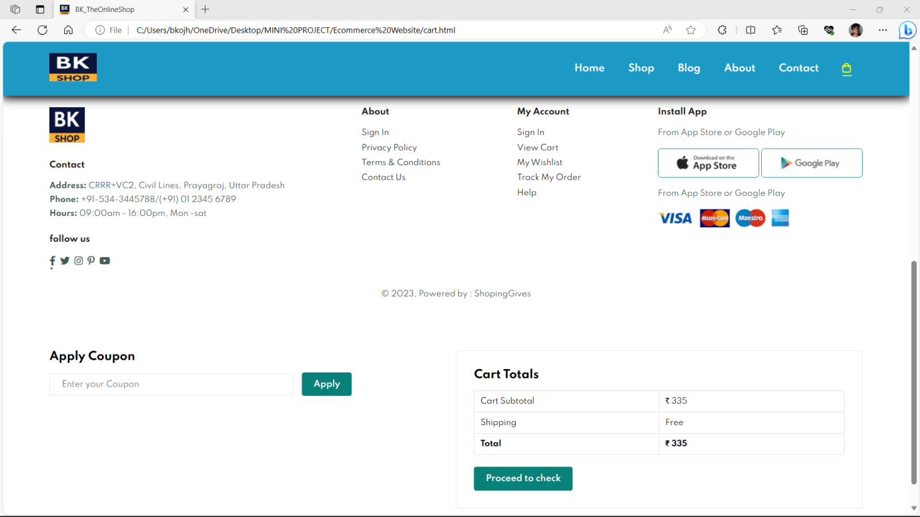

**Login Page**

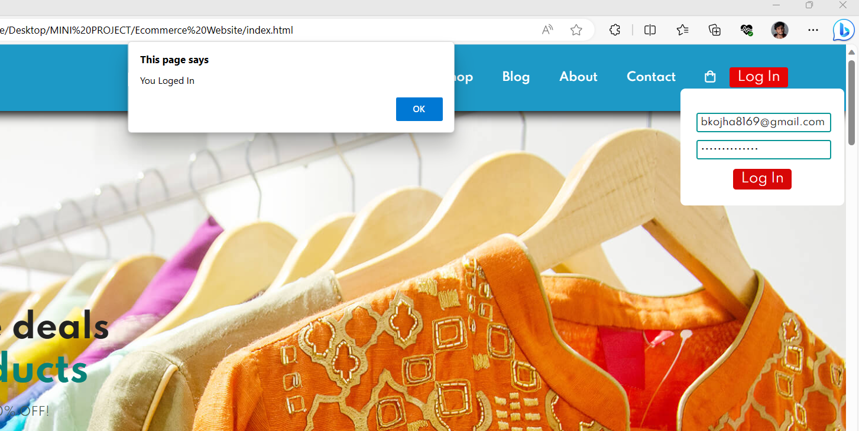

**CODING**

**HTML: index.html**

<!DOCTYPE html>

<html lang="en">

<head>

    <meta charset="UTF-8">

    <meta http-equiv="X-UA-Compatible" content="IE=edge">

    <meta name="viewport" content="width=device-width, initial-scale=1.0">

    <title>BK_TheOnlineShop</title>

<link rel="stylesheet" href="https://pro.fontawesome.com/releases/v5.10.0/css/all.css" />

    <link rel="shortcut icon" href="bk1.png" type="x-icon">

    <link rel="stylesheet" href="style.css">

</head>

<body>

    <section id="header">

        <a href="#"><img src="bk1.png" class="logo" alt=""></a>

        <div>

            <ul id="navbar">

                <li><a class="active" href="index.html">Home</a></li>

                <li><a href="shop.html">Shop</a></li>

                <li><a href="blog.html">Blog</a></li>

                <li><a href="about.html">About</a></li>

                <li><a href="contact.html">Contact</a></li>

          <li id="lg-bag"><a href="cart.html"><i class="far fa- shopping-bag"></i></a></li>

                <a href="#" id="close"><i class="far fa-times"></i></a>

                <button id="login">Log In</button>

                <!-- login -->

                <div class="loginPage">

                    <input type="text" placeholder="Enter Email" id="email">

                    <input type="password" placeholder="Enter Password" id="pass">

                    <button id="loged">Log In</button>

                </div>

            </ul>

        </div>

        <div id="mobile">

            <a href="cart.html"><i class="far fa-shopping-bag"></i></a>

            <i id="bar" class="fas fa-outdent"></i>

        </div>

</section>

    <section id="hero">

        <h4>Trade-in-offer</h4>

        <h2>Super value deals</h2>

        <h1>On all products</h1>

        <p>Save more with coupons & up to 70% OFF! </p>

        <button>Shop Now</button>

    </section>

    <section id="feature" class="section-p1">

        <div class="fe-box">

            <img src="features//f1.png" alt="">

            <h6>Free Shipping</h6>

        </div><div class="fe-box">

            <img src="features//f2.png" alt="">

            <h6>Online Order</h6>

        </div><div class="fe-box">

            <img src="features//f3.png" alt="">

            <h6>Save Money</h6>

        </div><div class="fe-box">

            <img src="features//f4.png" alt="">

            <h6>Promotions</h6>

        </div><div class="fe-box">

            <img src="features//f5.png" alt="">

            <h6>Happy Sells</h6>

        </div>

        <div class="fe-box">

            <img src="features//f6.png" alt="">

            <h6>Support</h6>

        </div>

    </section>

    <section id="product1" class="section-p1">

        <h2>Featured products</h2>

        <p>Summer Collection New Morden Design</p>

        <div class="pro-container">

            <div class="pro">

                <img src="products/f1.jpg" alt="">

                <div class="des">

                    <span>adidas</span>

                    <h5>Cartoon Astronaut Shirt</h5>

                    <div class="star">

                        <i class="fas fa-star"></i>

                        <i class="fas fa-star"></i>

                        <i class="fas fa-star"></i>

                        <i class="fas fa-star"></i>

                        <i class="fas fa-star"></i>

                    </div>

                    <h4>&#8377; 99</h4>

                </div>

                <a href="#"><i class="fal fa-shopping-cart cart"></i></a>

            </div>

            <div class="pro">

                <img src="products/f2.jpg" alt="">

                <div class="des">

                    <span>N AND J</span>

                    <h5>Men Slim Fit Printed Spread Collar Casual Shirt</h5>

                    <div class="star">

                        <i class="fas fa-star"></i>

                        <i class="fas fa-star"></i>

                        <i class="fas fa-star"></i>

                        <i class="fas fa-star"></i>

                        <i class="fas fa-star"></i>

                    </div>

                    <h4>&#8377; 149</h4>

                </div>

                <a href="#"><i class="fal fa-shopping-cart cart"></i></a>

            </div>

            <div class="pro">

                <img src="products/f3.jpg" alt="">

                <div class="des">

                    <span>VeBNoR</span>

                    <h5>Men Slim Fit Printed Spread Collar Casual Shirt</h5>

                    <div class="star">

                        <i class="fas fa-star"></i>

                        <i class="fas fa-star"></i>

                        <i class="fas fa-star"></i>

                        <i class="fas fa-star"></i>

                        <i class="fas fa-star"></i>

                    </div>

                    <h4>&#8377; 149</h4>

                </div>

                <a href="#"><i class="fal fa-shopping-cart cart"></i></a>

            </div>

            <div class="pro">

                <img src="products/f4.jpg" alt="">

                <div class="des">

                    <span>VeBNoR</span>

                    <h5>Men Regular Fit Printed Spread Collar Casual Shirt</h5>

                    <div class="star">

                        <i class="fas fa-star"></i>

                        <i class="fas fa-star"></i>

                        <i class="fas fa-star"></i>

                        <i class="fas fa-star"></i>

                        <i class="fas fa-star"></i>

                    </div>

                    <h4>&#8377; 199</h4>

                </div>

                <a href="#"><i class="fal fa-shopping-cart cart"></i></a>

            </div>

            <div class="pro">

                <img src="products/f5.jpg" alt="">

                <div class="des">

                    <span>VeBNoR</span>

                    <h5>Men Regular Fit Printed Spread Collar Casual Shirt</h5>

                    <div class="star">

                        <i class="fas fa-star"></i>

                        <i class="fas fa-star"></i>

                        <i class="fas fa-star"></i>

                        <i class="fas fa-star"></i>

                        <i class="fas fa-star"></i>

                    </div>

                    <h4>&#8377; 199</h4>

                </div>

                <a href="#"><i class="fal fa-shopping-cart cart"></i></a>

            </div>

            <div class="pro">

                <img src="products/f6.jpg" alt="">

                <div class="des">

                    <span>GreenFlair</span>

                    <h5>Men Regular Fit Solid Spread Collar Casual Shirt</h5>

                    <div class="star">

                        <i class="fas fa-star"></i>

                        <i class="fas fa-star"></i>

                        <i class="fas fa-star"></i>

                        <i class="fas fa-star"></i>

                        <i class="fas fa-star"></i>

                    </div>

                    <h4>&#8377; 249</h4>

                </div>

                <a href="#"><i class="fal fa-shopping-cart cart"></i></a>

            </div>

            <div class="pro">

                <img src="products/f7.jpg" alt="">

                <div class="des">

                    <span>Raymond</span>

                    <h5>Men Slim Fit Brown Viscose Rayon Trousers</h5>

                    <div class="star">

                        <i class="fas fa-star"></i>

                        <i class="fas fa-star"></i>

                        <i class="fas fa-star"></i>

                        <i class="fas fa-star"></i>

                        <i class="fas fa-star"></i>

                    </div>

                    <h4>&#8377; 249</h4>

                </div>

                <a href="#"><i class="fal fa-shopping-cart cart"></i></a>

            </div>

            <div class="pro">

                <img src="products/f8.jpg" alt="">

                <div class="des">

                    <span>SPOQUE</span>

                    <h5>Men Solid Pure Cotton Straight Kurta</h5>

                    <div class="star">

                        <i class="fas fa-star"></i>

                        <i class="fas fa-star"></i>

                        <i class="fas fa-star"></i>

                        <i class="fas fa-star"></i>

                        <i class="fas fa-star"></i>

                    </div>

                    <h4>&#8377; 399</h4>

                </div>

                <a href="#"><i class="fal fa-shopping-cart cart"></i></a>

            </div>

        </div>

    </section>

    <section id="banner" class="section-m1">

        <h4>Repair Services</h4>

        <h2>Up to <span> 70% OFF</span> - All Shirt & Accessories</h2>

        <button class="normal">Explore More</button>

    </section>

    <section id="product1" class="section-p1">

        <h2>New Arrivals</h2>

        <p>Summer Collection New Morden Design</p>

        <div class="pro-container">

            <div class="pro">

                <img src="products/n1.jpg" alt="">

                <div class="des">

                    <span>SOPANI</span>

                    <h5>Men Solid Cotton Blend Straight Kurta</h5>

                    <div class="star">

                        <i class="fas fa-star"></i>

                        <i class="fas fa-star"></i>

                        <i class="fas fa-star"></i>

                        <i class="fas fa-star"></i>

                        <i class="fas fa-star"></i>

                    </div>

                    <h4>&#8377; 99</h4>

                </div>

                <a href="#"><i class="fal fa-shopping-cart cart"></i></a>

            </div>

            <div class="pro">

                <img src="products/n2.jpg" alt="">

                <div class="des">

                    <span>ETHNEECLOOK</span>

                    <h5>Men Regular Fit Solid Beach Wear Shirt</h5>

                    <div class="star">

                        <i class="fas fa-star"></i>

                        <i class="fas fa-star"></i>

                        <i class="fas fa-star"></i>

                        <i class="fas fa-star"></i>

                        <i class="fas fa-star"></i>

                    </div>

                    <h4>&#8377; 99</h4>

                </div>

                <a href="#"><i class="fal fa-shopping-cart cart"></i></a>

            </div>

            <div class="pro">

                <img src="products/n3.jpg" alt="">

                <div class="des">

                    <span>Majestic Man</span>

                    <h5>Men Slim Fit Checkered Spread Collar Casual Shirt</h5>

                    <div class="star">

                        <i class="fas fa-star"></i>

                        <i class="fas fa-star"></i>

                        <i class="fas fa-star"></i>

                        <i class="fas fa-star"></i>

                        <i class="fas fa-star"></i>

                    </div>

                    <h4>&#8377; 149</h4>

                </div>

                <a href="#"><i class="fal fa-shopping-cart cart"></i></a>

            </div>

            <div class="pro">

                <img src="products/n4.jpg" alt="">

                <div class="des">

                    <span>BBC</span>

                    <h5>Men Regular Fit Printed Cut Away Collar Casual Shirt</h5>

                    <div class="star">

                        <i class="fas fa-star"></i>

                        <i class="fas fa-star"></i>

                        <i class="fas fa-star"></i>

                        <i class="fas fa-star"></i>

                        <i class="fas fa-star"></i>

                    </div>

                    <h4>&#8377; 199</h4>

                </div>

                <a href="#"><i class="fal fa-shopping-cart cart"></i></a>

            </div>

            <div class="pro">

                <img src="products/n5.jpg" alt="">

                <div class="des">

                    <span>VeBNoR</span>

                    <h5>Men Regular Fit Solid Spread Collar Casual Shirt</h5>

                    <div class="star">

                        <i class="fas fa-star"></i>

                        <i class="fas fa-star"></i>

                        <i class="fas fa-star"></i>

                        <i class="fas fa-star"></i>

                        <i class="fas fa-star"></i>

                    </div>

                    <h4>&#8377; 199</h4>

                </div>

                <a href="#"><i class="fal fa-shopping-cart cart"></i></a>

            </div>

            <div class="pro">

                <img src="products/n6.jpg" alt="">

                <div class="des">

                    <span>Damensch</span>

                    <h5>Pack of 2 Cotton Back Pocket Printed Men Boxer</h5>

                    <div class="star">

                        <i class="fas fa-star"></i>

                        <i class="fas fa-star"></i>

                        <i class="fas fa-star"></i>

                        <i class="fas fa-star"></i>

                        <i class="fas fa-star"></i>

                    </div>

                    <h4>&#8377; 199</h4>

                </div>

                <a href="#"><i class="fal fa-shopping-cart cart"></i></a>

            </div>

            <div class="pro">

                <img src="products/n7.jpg" alt="">

                <div class="des">

                    <span>ALMORA</span>

                    <h5>Men Regular Fit Solid Slim Collar Casual Shirt</h5>

                    <div class="star">

                        <i class="fas fa-star"></i>

                        <i class="fas fa-star"></i>

                        <i class="fas fa-star"></i>

                        <i class="fas fa-star"></i>

                        <i class="fas fa-star"></i>

                    </div>

                    <h4>&#8377; 299</h4>

                </div>

                <a href="#"><i class="fal fa-shopping-cart cart"></i></a>

            </div>

            <div class="pro">

                <img src="products/n8.jpg" alt="">

                <div class="des">

                    <span>Regrowth</span>

                    <h5>Men Regular Fit Solid Casual Shirt</h5>

                    <div class="star">

                        <i class="fas fa-star"></i>

                        <i class="fas fa-star"></i>

                        <i class="fas fa-star"></i>

                        <i class="fas fa-star"></i>

                        <i class="fas fa-star"></i>

                    </div>

                    <h4>&#8377; 349</h4>

                </div>

                <a href="#"><i class="fal fa-shopping-cart cart"></i></a>

            </div>

        </div>

    </section>

    <section id="sm-banner" class="section-p1">

        <div class="banner-box">

           <h4>crazy deals</h4>

           <h2>buy 1 get 1 free</h2>

           <span>The best classic dress is on sale at BK Shop</span>

           <button class="white">Learn More</button>

        </div>

        <div class="banner-box banner-box2">

            <h4>spiring/summer</h4>

            <h2>buy 1 get 1 free</h2>

            <span>The best classic dress is on sale at Bk Shop</span>

            <button class="white">Collection</button>

         </div>

    </section>

    <section id="banner3">

    <div class="banner-box">

        <h2>SEASONAL SALE</h2>

        <h3>Winter Collection -50% OFF</h3>

     </div>

     <div class="banner-box banner-box2">

        <h2>NEW FOOTWEAR COLLECTION</h2>

        <h3>Spiring/Summer 2023</h3>

     </div>

     <div class="banner-box banner-box3">

        <h2>T-SHIRTS</h2>

        <h3>New Trendy Prints</h3>

     </div>

    </section>

    <section id="newsletter" class="section-p1 section-m1">

        <div class="newstext">

            <h4>Sign Up For Newsletters</h4>

            <p>Get E-mail updates about our latest shop  and <span>special offers.</span></p>

        </div>

        <div class="form">

            <input type="text" placeholder="Your email address">

            <button class="normal">Sign Up</button>

        </div>

    </section>

    <footer class="section-p1">

        <div class="col">

            <img class="logo" src="bk1.png" width="60px" height=60px" alt="">

            <h4>Contact</h4>

            <p><strong>Address: </strong>  CRRR+VC2, Civil Lines, Prayagraj, Uttar Pradesh</p>

            <p><strong>Phone: </strong> +91-534-3445788/(+91) 01 2345 6789</p>

            <p><strong>Hours: </strong> 09:00am - 16:00pm, Mon -sat</p>

            <div class="follow">

                <h4>follow us</h4>

                <div class="icon">

                    <i class="fab fa-facebook-f"></i>

                    <i class="fab fa-twitter"></i>

                    <i class="fab fa-instagram"></i>

                    <i class="fab fa-pinterest-p"></i>

                    <i class="fab fa-youtube"></i>

                </div>

            </div>"

        </div>

        <div class="col">

            <h4>About</h4>

            <a href="#">Sign In</a>

            <a href="#">Privacy Policy</a>

            <a href="#">Terms & Conditions</a>

            <a href="#">Contact Us</a>

        </div>

        <div class="col">

            <h4>My Account</h4>

            <a href="#">Sign In</a>

            <a href="#">View Cart</a>

            <a href="#">My Wishlist</a>

            <a href="#">Track My Order</a>

            <a href="#">Help</a>

        </div>

        <div class="col install">

            <h4>Install App</h4>

            <p>From App Store or Google Play</p>

            <div class="row">

                <img src="pay/app.jpg" alt="">

                <img src="pay/play.jpg" alt="">

            </div>

            <p>From App Store or Google Play</p>

            <img src="pay/pay.png" alt="">

        </div>

        <div class="copyright">

            <p>&copy; 2023, Powered by : BkShop</p>

        </div>

    </footer>

    <script src="script.js"></script>

</body>

</html>

**HTML: shop.html**

<!DOCTYPE html>

<html lang="en">

<head>

    <meta charset="UTF-8">

    <meta http-equiv="X-UA-Compatible" content="IE=edge">

    <meta name="viewport" content="width=device-width, initial-scale=1.0">

    <title>BK_TheOnlineShop</title>

    <link rel="stylesheet" href="https://pro.fontawesome.com/releases/v5.10.0/css/all.css" />

    <link rel="shortcut icon" href="bk1.png" type="x-icon">

    <link rel="stylesheet" href="style.css">

</head>

<body>

    <section id="header">

        <a href="#"><img src="bk1.png" class="logo" alt=""></a>

        <div>

            <ul id="navbar">

                <li><a href="index.html">Home</a></li>

                <li><a class="active" href="shop.html">Shop</a></li>

                <li><a href="blog.html">Blog</a></li>

                <li><a href="about.html">About</a></li>

                <li><a href="contact.html">Contact</a></li>

                <li id="lg-bag"><a href="cart.html"><i class="far fa-shopping-bag"></i></a></li>

                <a href="#" id="close"><i class="far fa-times"></i></a>

            </ul>

        </div>

        <div id="mobile">

            <a href="cart.html"><i class="far fa-shopping-bag"></i></a>

            <i id="bar" class="fas fa-outdent"></i>

        </div>

    </section>

    <section id="page-header">

        <h2>#stayhome</h2>

        <p>Save more with coupons & up to 70% OFF! </p>

    </section>

    <section id="product1" class="section-p1">

        <div class="pro-container">

            <div class="pro" onclick="window.location.href='sproduct.html';">

                <img src="products/f1.jpg" alt="">

                <div class="des">

                    <span>adidas</span>

                    <h5>Cartoon Astronaut Shirt</h5>

                    <div class="star">

                        <i class="fas fa-star"></i>

                        <i class="fas fa-star"></i>

                        <i class="fas fa-star"></i>

                        <i class="fas fa-star"></i>

                        <i class="fas fa-star"></i>

                    </div>

                    <h4>&#8377; 99</h4>

                </div>

                <a href="#"><i class="fal fa-shopping-cart cart"></i></a>

            </div>

            <div class="pro">

                <img src="products/f2.jpg" alt="">

                <div class="des">

                    <span>N AND J </span>

                    <h5>Men Slim Fit Printed Spread Collar Casual Shirt</h5>

                    <div class="star">

                        <i class="fas fa-star"></i>

                        <i class="fas fa-star"></i>

                        <i class="fas fa-star"></i>

                        <i class="fas fa-star"></i>

                        <i class="fas fa-star"></i>

                    </div>

                    <h4>&#8377; 149</h4>

                </div>

                <a href="#"><i class="fal fa-shopping-cart cart"></i></a>

            </div>

            <div class="pro">

                <img src="products/f3.jpg" alt="">

                <div class="des">

                    <span>VeBNoR</span>

                    <h5>Men Slim Fit Printed Spread Collar Casual Shirt</h5>

                    <div class="star">

                        <i class="fas fa-star"></i>

                        <i class="fas fa-star"></i>

                        <i class="fas fa-star"></i>

                        <i class="fas fa-star"></i>

                        <i class="fas fa-star"></i>

                    </div>

                    <h4>&#8377; 149</h4>

                </div>

                <a href="#"><i class="fal fa-shopping-cart cart"></i></a>

            </div>

            <div class="pro">

                <img src="products/f4.jpg" alt="">

                <div class="des">

                    <span>VeBNoR</span>

                    <h5>Men Regular Fit Printed Spread Collar Casual Shirt</h5>

                    <div class="star">

                        <i class="fas fa-star"></i>

                        <i class="fas fa-star"></i>

                        <i class="fas fa-star"></i>

                        <i class="fas fa-star"></i>

                        <i class="fas fa-star"></i>

                    </div>

                    <h4>&#8377; 199</h4>

                </div>

                <a href="#"><i class="fal fa-shopping-cart cart"></i></a>

            </div>

            <div class="pro">

                <img src="products/f5.jpg" alt="">

                <div class="des">

                    <span>VeBNoR</span>

                    <h5>Men Regular Fit Printed Spread Collar Casual  Shirt</h5>

                    <div class="star">

                        <i class="fas fa-star"></i>

                        <i class="fas fa-star"></i>

                        <i class="fas fa-star"></i>

                        <i class="fas fa-star"></i>

                        <i class="fas fa-star"></i>

                    </div>

                    <h4>&#8377; 199</h4>

                </div>

                <a href="#"><i class="fal fa-shopping-cart cart"></i></a>

            </div>

            <div class="pro">

                <img src="products/f6.jpg" alt="">

                <div class="des">

                    <span>GreenFlair</span>

                    <h5>Men Regular Fit Solid Spread Collar Casual Shirt</h5>

                    <div class="star">

                        <i class="fas fa-star"></i>

                        <i class="fas fa-star"></i>

                        <i class="fas fa-star"></i>

                        <i class="fas fa-star"></i>

                        <i class="fas fa-star"></i>

                    </div>

                    <h4>&#8377; 249</h4>

                </div>

                <a href="#"><i class="fal fa-shopping-cart cart"></i></a>

            </div>

            <div class="pro">

                <img src="products/f7.jpg" alt="">

                <div class="des">

                    <span>Raymond</span>

                    <h5>Men Slim Fit Brown Viscose Rayon Trousers</h5>

                    <div class="star">

                        <i class="fas fa-star"></i>

                        <i class="fas fa-star"></i>

                        <i class="fas fa-star"></i>

                        <i class="fas fa-star"></i>

                        <i class="fas fa-star"></i>

                    </div>

                    <h4>&#8377; 249</h4>

                </div>

                <a href="#"><i class="fal fa-shopping-cart cart"></i></a>

            </div>

            <div class="pro">

                <img src="products/f8.jpg" alt="">

                <div class="des">

                    <span>SPOQUE</span>

                    <h5>Men Solid Pure Cotton Straight Kurta</h5>

                    <div class="star">

                        <i class="fas fa-star"></i>

                        <i class="fas fa-star"></i>

                        <i class="fas fa-star"></i>

                        <i class="fas fa-star"></i>

                        <i class="fas fa-star"></i>

                    </div>

                    <h4>&#8377; 399</h4>

                </div>

                <a href="#"><i class="fal fa-shopping-cart cart"></i></a>

            </div>

            <div class="pro">

                <img src="products/n1.jpg" alt="">

                <div class="des">

                    <span>SOPANI</span>

                    <h5>Men Solid Cotton Blend Straight Kurta </h5>

                    <div class="star">

                        <i class="fas fa-star"></i>

                        <i class="fas fa-star"></i>

                        <i class="fas fa-star"></i>

                        <i class="fas fa-star"></i>

                        <i class="fas fa-star"></i>

                    </div>

                    <h4>&#8377; 99</h4>

                </div>

                <a href="#"><i class="fal fa-shopping-cart cart"></i></a>

            </div>

            <div class="pro">

                <img src="products/n2.jpg" alt="">

                <div class="des">

                    <span>ETHNEECLOOK</span>

                    <h5>Men Regular Fit Solid Beach Wear Shirt</h5>

                    <div class="star">

                        <i class="fas fa-star"></i>

                        <i class="fas fa-star"></i>

                        <i class="fas fa-star"></i>

                        <i class="fas fa-star"></i>

                        <i class="fas fa-star"></i>

                    </div>

                    <h4>&#8377; 99</h4>

                </div>

                <a href="#"><i class="fal fa-shopping-cart cart"></i></a>

            </div>

            <div class="pro">

                <img src="products/n3.jpg" alt="">

                <div class="des">

                    <span>Majestic Man </span>

                    <h5>Men Slim Fit Checkered Spread Collar Casual Shirt</h5>

                    <div class="star">

                        <i class="fas fa-star"></i>

                        <i class="fas fa-star"></i>

                        <i class="fas fa-star"></i>

                        <i class="fas fa-star"></i>

                        <i class="fas fa-star"></i>

                    </div>

                    <h4>&#8377; 149</h4>

                </div>

                <a href="#"><i class="fal fa-shopping-cart cart"></i></a>

            </div>

            <div class="pro">

                <img src="products/n4.jpg" alt="">

                <div class="des">

                    <span>BBC</span>

                    <h5>Men Regular Fit Printed Cut Away Collar Casual Shirt</h5>

                    <div class="star">

                        <i class="fas fa-star"></i>

                        <i class="fas fa-star"></i>

                        <i class="fas fa-star"></i>

                        <i class="fas fa-star"></i>

                        <i class="fas fa-star"></i>

                    </div>

                    <h4>&#8377; 199</h4>

                </div>

                <a href="#"><i class="fal fa-shopping-cart cart"></i></a>

            </div>

            <div class="pro">

                <img src="products/n5.jpg" alt="">

                <div class="des">

                    <span>VeBNoR</span>

                    <h5>Men Regular Fit Solid Spread Collar Casual Shirt</h5>

                    <div class="star">

                        <i class="fas fa-star"></i>

                        <i class="fas fa-star"></i>

                        <i class="fas fa-star"></i>

                        <i class="fas fa-star"></i>

                        <i class="fas fa-star"></i>

                    </div>

                    <h4>&#8377; 199</h4>

                </div>

                <a href="#"><i class="fal fa-shopping-cart cart"></i></a>

            </div>

            <div class="pro">

                <img src="products/n6.jpg" alt="">

                <div class="des">

                    <span>Damensch</span>

                    <h5>Pack of 2 Cotton Back Pocket Printed Men Boxer</h5>

                    <div class="star">

                        <i class="fas fa-star"></i>

                        <i class="fas fa-star"></i>

                        <i class="fas fa-star"></i>

                        <i class="fas fa-star"></i>

                        <i class="fas fa-star"></i>

                    </div>

                    <h4>&#8377; 199</h4>

                </div>

                <a href="#"><i class="fal fa-shopping-cart cart"></i></a>

            </div>

            <div class="pro">

                <img src="products/n7.jpg" alt="">

                <div class="des">

                    <span>ALMORA</span>

                    <h5>Men Regular Fit Solid Slim Collar Casual Shirt</h5>

                    <div class="star">

                        <i class="fas fa-star"></i>

                        <i class="fas fa-star"></i>

                        <i class="fas fa-star"></i>

                        <i class="fas fa-star"></i>

                        <i class="fas fa-star"></i>

                    </div>

                    <h4>&#8377; 299</h4>

                </div>

                <a href="#"><i class="fal fa-shopping-cart cart"></i></a>

            </div>

            <div class="pro">

                <img src="products/n8.jpg" alt="">

                <div class="des">

                    <span>Regrowth</span>

                    <h5>Men Regular Fit Solid Casual Shirt</h5>

                    <div class="star">

                        <i class="fas fa-star"></i>

                        <i class="fas fa-star"></i>

                        <i class="fas fa-star"></i>

                        <i class="fas fa-star"></i>

                        <i class="fas fa-star"></i>

                    </div>

                    <h4>&#8377; 349</h4>

                </div>

                <a href="#"><i class="fal fa-shopping-cart cart"></i></a>

            </div>

        </div>

    </section>

    <section id="pagination" class="section-p1">

        <a href="#">1</a>

        <a href="#">2</a>

        <a href="#"><i class="fal fa-long-arrow-alt-right"></i></a>

    </section>

    <section id="newsletter" class="section-p1 section-m1">

        <div class="newstext">

            <h4>Sign Up For Newsletters</h4>

            <p>Get E-mail updates about our latest shop  and <span>special offers.</span></p>

        </div>

        <div class="form">

            <input type="text" placeholder="Your email address">

            <button class="normal">Sign Up</button>

        </div>

    </section>

    <footer class="section-p1">

        <div class="col">

            <img class="logo" src="bk1.png" width="60px" height=60px" alt="">

            <h4>Contact</h4>

            <p><strong>Address: </strong>  CRRR+VC2, Civil Lines, Prayagraj, Uttar Pradesh</p>

            <p><strong>Phone: </strong> +91-534-3445788/(+91) 01 2345 6789</p>

            <p><strong>Hours: </strong> 09:00am - 16:00pm, Mon -sat</p>

            <div class="follow">

                <h4>follow us</h4>

                <div class="icon">

                    <i class="fab fa-facebook-f"></i>

                    <i class="fab fa-twitter"></i>

                    <i class="fab fa-instagram"></i>

                    <i class="fab fa-pinterest-p"></i>

                    <i class="fab fa-youtube"></i>

                </div>

            </div>"

        </div>

        <div class="col">

            <h4>About</h4>

            <a href="#">Sign In</a>

            <a href="#">Privacy Policy</a>

            <a href="#">Terms & Conditions</a>

            <a href="#">Contact Us</a>

        </div>

        <div class="col">

            <h4>My Account</h4>

            <a href="#">Sign In</a>

            <a href="#">View Cart</a>

            <a href="#">My Wishlist</a>

            <a href="#">Track My Order</a>

            <a href="#">Help</a>

        </div>

        <div class="col install">

            <h4>Install App</h4>

            <p>From App Store or Google Play</p>

            <div class="row">

                <img src="pay/app.jpg" alt="">

                <img src="pay/play.jpg" alt="">

            </div>

            <p>From App Store or Google Play</p>

            <img src="pay/pay.png" alt="">

        </div>

        <div class="copyright">

            <p>&copy; 2023, Powered by : BkShop </p>

        </div>

    </footer>

    <script src="script.js"></script>

</body>

</html>

**HTML: sproduct.html**

<!DOCTYPE html>

<html lang="en">

<head>

    <meta charset="UTF-8">

    <meta http-equiv="X-UA-Compatible" content="IE=edge">

    <meta name="viewport" content="width=device-width, initial-scale=1.0">

    <title>BK_TheOnlineShop</title>

    <link rel="stylesheet" href="https://pro.fontawesome.com/releases/v5.10.0/css/all.css" />

    <link rel="shortcut icon" href="bk1.png" type="x-icon">

    <link rel="stylesheet" href="style.css">

</head>

<body>

    <section id="header">

        <a href="#"><img src="bk1.png" class="logo" alt=""></a>

        <div>

            <ul id="navbar">

                <li><a href="index.html">Home</a></li>

                <li><a class="active" href="shop.html">Shop</a></li>

                <li><a href="blog.html">Blog</a></li>

                <li><a href="about.html">About</a></li>

                <li><a href="contact.html">Contact</a></li>

                <li id="lg-bag"><a href="cart.html"><i class="far fa-shopping-bag"></i></a></li>

                <a href="#" id="close"><i class="far fa-times"></i></a>

            </ul>

        </div>

        <div id="mobile">

            <a href="cart.html"><i class="far fa-shopping-bag"></i></a>

            <i id="bar" class="fas fa-outdent"></i>

        </div>

    </section>

    <section id="prodetails" class="section-p1">

        <div class="single-pro-image">

            <img src="products/f1.jpg" width="100%" id="MainImg" alt="">

            <div class="small-img-group">

                <div class="small-img-col">

                    <img src="products/f1.jpg" width="100%" class="small-img" alt="">

                </div>

                <div class="small-img-col">

                    <img src="products/f2.jpg" width="100%" class="small-img" alt="">

                </div>

                <div class="small-img-col">

                    <img src="products/f3.jpg" width="100%" class="small-img" alt="">

                </div>

                <div class="small-img-col">

                    <img src="products/f4.jpg" width="100%" class="small-img" alt="">

                </div>

            </div>

        </div>

        <div class="single-pro-details">

            <h6>Home / Shirts</h6>

            <h4>Men's Fashion Shirt</h4>

            <h2>&#8377; 99.00</h2>

            <select>

                <option>Select Size</option>

                <option>XL</option>

                <option>XXL</option>

                <option>Small</option>

                <option>Large</option>

            </select>

            <input type="number" value="1">

            <button class="normal">Add To cart</button>

            <h4>Product Details</h4>

            <span>

                <li><b>Care Instructions:</b> Machine Wash</li>

                <li><b>Date First Available:</b> 9 October 2023</li>

                <li><b>Item Part Number:</b> FH-printed-shirt-1</li>

                <li><b>Country of Origin:</b> India</li>

                <li><b>Department:</b> Men</li>

                <li><b>Item Weight:</b> 230 g</li>

                <li><b>Fit Type:</b> Rgular Fit</li>

                <li>Perfect for Casual, Evening, Holiday wear.</li>

                <li>Stylish & Trendy Graphic Printed Shirt.</li>

                <li>Material fabric Cotton blend Feels soft & comfortable.</li>

                <li>Wash Care - Mild Wash ; Wash dark colors separately.</li>

                <br>

                <marquee bgcolor="#ccc" loop="-1" scrollamount="5" width="100%">There

                    may be slight variation in shade and colour due to photographic effects and monitor settings.</marquee>

            </span>

        </div>

    </section>

    <section id="product1" class="section-p1">

        <h2>New Arrivals</h2>

        <p>Summer Collection New Morden Design</p>

        <div class="pro-container">

            <div class="pro">

                <img src="products/n1.jpg" alt="">

                <div class="des">

                    <span>SOPANI</span>

                    <h5>Men Solid Cotton Blend Straight Kurta</h5>

                    <div class="star">

                        <i class="fas fa-star"></i>

                        <i class="fas fa-star"></i>

                        <i class="fas fa-star"></i>

                        <i class="fas fa-star"></i>

                        <i class="fas fa-star"></i>

                    </div>

                    <h4>&#8377; 99</h4>

                </div>

                <a href="#"><i class="fal fa-shopping-cart cart"></i></a>

            </div>

            <div class="pro">

                <img src="products/n2.jpg" alt="">

                <div class="des">

                    <span>ETHNEECLOOK</span>

                    <h5>Men Regular Fit Solid Beach Wear Shirt</h5>

                    <div class="star">

                        <i class="fas fa-star"></i>

                        <i class="fas fa-star"></i>

                        <i class="fas fa-star"></i>

                        <i class="fas fa-star"></i>

                        <i class="fas fa-star"></i>

                    </div>

                    <h4>&#8377; 99</h4>

                </div>

                <a href="#"><i class="fal fa-shopping-cart cart"></i></a>

            </div>

            <div class="pro">

                <img src="products/n3.jpg" alt="">

                <div class="des">

                    <span>Majestic Man</span>

                    <h5>Men Slim Fit Checkered Spread Collar Casual Shirt</h5>

                    <div class="star">

                        <i class="fas fa-star"></i>

                        <i class="fas fa-star"></i>

                        <i class="fas fa-star"></i>

                        <i class="fas fa-star"></i>

                        <i class="fas fa-star"></i>

                    </div>

                    <h4>&#8377; 149</h4>

                </div>

                <a href="#"><i class="fal fa-shopping-cart cart"></i></a>

            </div>

            <div class="pro">

                <img src="products/n4.jpg" alt="">

                <div class="des">

                    <span>BBC</span>

                    <h5>Men Regular Fit Printed Cut Away Collar Casual Shirt</h5>

                    <div class="star">

                        <i class="fas fa-star"></i>

                        <i class="fas fa-star"></i>

                        <i class="fas fa-star"></i>

                        <i class="fas fa-star"></i>

                        <i class="fas fa-star"></i>

                    </div>

                    <h4>&#8377; 199</h4>

                </div>

                <a href="#"><i class="fal fa-shopping-cart cart"></i></a>

            </div>

        </div>

    </section>

    <section id="newsletter" class="section-p1 section-m1">

        <div class="newstext">

            <h4>Sign Up For Newsletters</h4>

            <p>Get E-mail updates about our latest shop  and <span>special offers.</span></p>

        </div>

        <div class="form">

            <input type="text" placeholder="Your email address">

            <button class="normal">Sign Up</button>

        </div>

    </section>

    <footer class="section-p1">

        <div class="col">

            <img class="logo" src="bk1.png" width="60px" height=60px" alt="">

            <h4>Contact</h4>

            <p><strong>Address: </strong>  CRRR+VC2, Civil Lines, Prayagraj, Uttar Pradesh</p>

            <p><strong>Phone: </strong> +91-534-3445788/(+91) 01 2345 6789</p>

            <p><strong>Hours: </strong> 09:00am - 16:00pm, Mon -sat</p>

            <div class="follow">

                <h4>follow us</h4>

                <div class="icon">

                    <i class="fab fa-facebook-f"></i>

                    <i class="fab fa-twitter"></i>

                    <i class="fab fa-instagram"></i>

                    <i class="fab fa-pinterest-p"></i>

                    <i class="fab fa-youtube"></i>

                </div>

            </div>"

        </div>

        <div class="col">

            <h4>About</h4>

            <a href="#">Sign In</a>

            <a href="#">Privacy Policy</a>

            <a href="#">Terms & Conditions</a>

            <a href="#">Contact Us</a>

        </div>

        <div class="col">

            <h4>My Account</h4>

            <a href="#">Sign In</a>

            <a href="#">View Cart</a>

            <a href="#">My Wishlist</a>

            <a href="#">Track My Order</a>

            <a href="#">Help</a>

        </div>

        <div class="col install">

            <h4>Install App</h4>

            <p>From App Store or Google Play</p>

            <div class="row">

                <img src="pay/app.jpg" alt="">

                <img src="pay/play.jpg" alt="">

            </div>

            <p>From App Store or Google Play</p>

            <img src="pay/pay.png" alt="">

        </div>

        <div class="copyright">

            <p>&copy; 2023, Powered by : BkShop </p>

        </div>

    </footer>

    <script>

        var MainImg = document.getElementById("MainImg");

        var smallimg=document.getElementsByClassName("small-img");

        smallimg[0].onclick=function(){

            MainImg.src=smallimg[0].src;

        }

        smallimg[1].onclick=function(){

            MainImg.src=smallimg[1].src;

        }

        smallimg[2].onclick=function(){

            MainImg.src=smallimg[2].src;

        }

        smallimg[3].onclick=function(){

            MainImg.src=smallimg[3].src;

        }

    </script>

    <script src="script.js"></script>

</body>

</html>

**HTML: blog.html**

<!DOCTYPE html>

<html lang="en">

<head>

    <meta charset="UTF-8">

    <meta http-equiv="X-UA-Compatible" content="IE=edge">

    <meta name="viewport" content="width=device-width, initial-scale=1.0">

    <title>BK_TheOnlineShop</title>

    <link rel="stylesheet" href="https://pro.fontawesome.com/releases/v5.10.0/css/all.css" />

    <link rel="shortcut icon" href="bk1.png" type="x-icon">

    <link rel="stylesheet" href="style.css">

</head>

<body>

    <section id="header">

        <a href="#"><img src="bk1.png" class="logo" alt=""></a>

        <div>

            <ul id="navbar">

                <li><a href="index.html">Home</a></li>

                <li><a href="shop.html">Shop</a></li>

                <li><a class="active" href="blog.html">Blog</a></li>

                <li><a href="about.html">About</a></li>

                <li><a href="contact.html">Contact</a></li>

                <li id="lg-bag"><a href="cart.html"><i class="far fa-shopping-bag"></i></a></li>

                <a href="#" id="close"><i class="far fa-times"></i></a>

            </ul>

        </div>

        <div id="mobile">

            <a href="cart.html"><i class="far fa-shopping-bag"></i></a>

            <i id="bar" class="fas fa-outdent"></i>

        </div>

    </section>

    <section id="page-header" class="blog-header">

        <h2>#readmore</h2>

        <p>Read all case studies about our products! </p>

    </section>

    <section id="blog">

        <div class="blog-box">

            <div class="blog-img">

                <img src="blog/b1.jpg" alt="">

            </div>

            <div class="blog-details">

                <h4>GIRL WITH CURVES</h4>

                <p>Let’s face it—the body type of models is far from reality. Slim people do exist in real life, but there are women with bigger sizes who can look just as good. People come in all shapes and sizes, but many of us have been conditioned to believe that only one body type is ideal for fashion....</p>

                <a href="#">CONTINUE READING</a>

                </div>

                <h1>13/01</h1>

        </div>

        <div class="blog-box">

            <div class="blog-img">

                <img src="blog/b2.jpg" alt="">

            </div>

            <div class="blog-details">

                <h4>WE WORE THAT</h4>

                <p>We Wore What is one of those remarkable blogs that have

                     found success as an online shop.<br>A self-taught photographer, she started with photographing street fashion in her campus....</p>

                <a href="#">CONTINUE READING</a>

                </div>

                <h1>13/03</h1>

        </div>

        <div class="blog-box">

            <div class="blog-img">

                <img src="blog/b3.jpg" alt="">

            </div>

            <div class="blog-details">

                <h4>WHAT MY BOYFRIEND WORE</h4>

                <p>What My Boyfriend Wore is not the blog of a fashion-forward girlfriend, but it did start out with creator Sergio Ines’

now former girlfriend posting photos of his outfits on Instagram.

This “fashion diary with a difference,” as Sergio describes it, is

all about fashion and styling for the ordinary man....</p>

                <a href="#">CONTINUE READING</a>

                </div>

                <h1>12/01</h1>

        </div>

        <div class="blog-box">

            <div class="blog-img">

                <img src="blog/b4.jpg" alt="">

            </div>

            <div class="blog-details">

                <h4>STYLISHLY ME</h4>

                <p>Stylishlyme has your usual fashion and style tips,

                    including posts on how to wear fashion pieces like midi dresses, boots, hats, and ankle strap heels. Aside from these,

Stylishlyme also dedicates a section of the website to personal growth....</p>

                <a href="#">CONTINUE READING</a>

                </div>

                <h1>16/01</h1>

        </div>

    </section>

    <section id="pagination" class="section-p1">

        <a href="#">1</a>

        <a href="#">2</a>

        <a href="#"><i class="fal fa-long-arrow-alt-right"></i></a>

    </section>

    <section id="newsletter" class="section-p1 section-m1">

        <div class="newstext">

            <h4>Sign Up For Newsletters</h4>

            <p>Get E-mail updates about our latest shop  and <span>special offers.</span></p>

        </div>

        <div class="form">

            <input type="text" placeholder="Your email address">

            <button class="normal">Sign Up</button>

        </div>

    </section>

    <footer class="section-p1">

        <div class="col">

            <img class="logo" src="bk1.png" width="60px" height=60px" alt="">

            <h4>Contact</h4>

            <p><strong>Address: </strong>  CRRR+VC2, Civil Lines, Prayagraj, Uttar Pradesh</p>

            <p><strong>Phone: </strong> +91-534-3445788/(+91) 01 2345 6789</p>

            <p><strong>Hours: </strong> 09:00am - 16:00pm, Mon -sat</p>

            <div class="follow">

                <h4>follow us</h4>

                <div class="icon">

                    <i class="fab fa-facebook-f"></i>

                    <i class="fab fa-twitter"></i>

                    <i class="fab fa-instagram"></i>

                    <i class="fab fa-pinterest-p"></i>

                    <i class="fab fa-youtube"></i>

                </div>

            </div>"

        </div>

        <div class="col">

            <h4>About</h4>

            <a href="#">Sign In</a>

            <a href="#">Privacy Policy</a>

            <a href="#">Terms & Conditions</a>

            <a href="#">Contact Us</a>

        </div>

        <div class="col">

            <h4>My Account</h4>

            <a href="#">Sign In</a>

            <a href="#">View Cart</a>

            <a href="#">My Wishlist</a>

            <a href="#">Track My Order</a>

            <a href="#">Help</a>

        </div>

        <div class="col install">

            <h4>Install App</h4>

            <p>From App Store or Google Play</p>

            <div class="row">

                <img src="pay/app.jpg" alt="">

                <img src="pay/play.jpg" alt="">

            </div>

            <p>From App Store or Google Play</p>

            <img src="pay/pay.png" alt="">

        </div>

        <div class="copyright">

            <p>&copy; 2023, Powered by : BkShop </p>

        </div>

    </footer>

    <script src="script.js"></script>

</body>

</html>

**HTML: about.html**

<!DOCTYPE html>

<html lang="en">

<head>

    <meta charset="UTF-8">

    <meta http-equiv="X-UA-Compatible" content="IE=edge">

    <meta name="viewport" content="width=device-width, initial-scale=1.0">

    <title>BK_TheOnlineShop</title>

    <link rel="stylesheet" href="https://pro.fontawesome.com/releases/v5.10.0/css/all.css" />

    <link rel="shortcut icon" href="bk1.png" type="x-icon">

    <link rel="stylesheet" href="style.css">

</head>

<body>

    <section id="header">

        <a href="#"><img src="bk1.png" class="logo" alt=""></a>

        <div>

            <ul id="navbar">

                <li><a href="index.html">Home</a></li>

                <li><a href="shop.html">Shop</a></li>

                <li><a href="blog.html">Blog</a></li>

                <li><a class="active" href="about.html">About</a></li>

                <li><a href="contact.html">Contact</a></li>

                <li id="lg-bag"><a href="cart.html"><i class="far fa-shopping-bag"></i></a></li>

                <a href="#" id="close"><i class="far fa-times"></i></a>

            </ul>

        </div>

        <div id="mobile">

            <a href="cart.html"><i class="far fa-shopping-bag"></i></a>

            <i id="bar" class="fas fa-outdent"></i>

        </div>

    </section>

    <section id="page-header" class="about-header">

        <h2>#KnowUs</h2>

        <p>Our shop is steeped in fostering trust, inclusion, support, recognition<br>

            and genuine care that enables Flipsters to create, innovate, <br>and bring

            their best selves to work.</p>

    </section>

    <section id="about-head" class="section-p1">

        <img src="about/a6.jpg" alt="">

        <div>

            <h2>Who We Are?</h2>

            <p>As a homegrown e-commerce organization, we direct our efforts towards building a sustainable business while creating inclusive

and impactfull growth for all our stakeholders. We believe in transformative innovation and risk-taking. We don't shy away from failure. We learn from our experiences and strive towards enhanced customer experiences while bridging the gap between Bharat and India with digital commerce.

            </p>

            <abbr title="">Create stunning images with as much or as little

                control as you<br>like thanks to a choice of Basic and Creative modes.

            </abbr>

            <br><br>

            <marquee bgcolor="#ccc" loop="-1" scrollamount="5" width="100%">Create stunning images with as much or as little

                control as youlike thanks to a choice of Basic and Creative modes.</marquee>

        </div>

    </section>

    <section id="about-app" class="section-p1">

        <h1>Download Our <a href="#">App</a></h1>

        <div class="video">

        <video autoplay muted loop src="about/1.mp4"></video>

        </div>

    </section>

    <section id="feature" class="section-p1">

        <div class="fe-box">

            <img src="features//f1.png" alt="">

            <h6>Free Shipping</h6>

        </div><div class="fe-box">

            <img src="features//f2.png" alt="">

            <h6>Online Order</h6>

        </div><div class="fe-box">

            <img src="features//f3.png" alt="">

            <h6>Save Money</h6>

        </div><div class="fe-box">

            <img src="features//f4.png" alt="">

            <h6>Promotions</h6>

        </div><div class="fe-box">

            <img src="features//f5.png" alt="">

            <h6>Happy Sells</h6>

        </div>

        <div class="fe-box">

            <img src="features//f6.png" alt="">

            <h6>Support</h6>

        </div>

    </section>

    <section id="newsletter" class="section-p1 section-m1">

        <div class="newstext">

            <h4>Sign Up For Newsletters</h4>

            <p>Get E-mail updates about our latest shop  and <span>special offers.</span></p>

        </div>

        <div class="form">

            <input type="text" placeholder="Your email address">

            <button class="normal">Sign Up</button>

        </div>

    </section>

    <footer class="section-p1">

        <div class="col">

            <img class="logo" src="bk1.png" width="60px" height=60px" alt="">

            <h4>Contact</h4>

            <p><strong>Address: </strong> CRRR+VC2, Civil Lines, Prayagraj, Uttar Pradesh</p>

            <p><strong>Phone: </strong> +91-534-3445788/(+91) 01 2345 6789</p>

            <p><strong>Hours: </strong> 09:00am - 16:00pm, Mon -sat</p>

            <div class="follow">

                <h4>follow us</h4>

                <div class="icon">

                    <i class="fab fa-facebook-f"></i>

                    <i class="fab fa-twitter"></i>

                    <i class="fab fa-instagram"></i>

                    <i class="fab fa-pinterest-p"></i>

                    <i class="fab fa-youtube"></i>

                </div>

            </div>"

        </div>

        <div class="col">

            <h4>About</h4>

            <a href="#">Sign In</a>

            <a href="#">Privacy Policy</a>

            <a href="#">Terms & Conditions</a>

            <a href="#">Contact Us</a>

        </div>

        <div class="col">

            <h4>My Account</h4>

            <a href="#">Sign In</a>

            <a href="#">View Cart</a>

            <a href="#">My Wishlist</a>

            <a href="#">Track My Order</a>

            <a href="#">Help</a>

        </div>

        <div class="col install">

            <h4>Install App</h4>

            <p>From App Store or Google Play</p>

            <div class="row">

                <img src="pay/app.jpg" alt="">

                <img src="pay/play.jpg" alt="">

            </div>

            <p>From App Store or Google Play</p>

            <img src="pay/pay.png" alt="">

        </div>

        <div class="copyright">

            <p>&copy; 2023, Powered by : BkShop </p>

        </div>

    </footer>

    <script src="script.js"></script>

</body>

</html>

**HTML: contact.html**

<!DOCTYPE html>

<html lang="en">

<head>

    <meta charset="UTF-8">

    <meta http-equiv="X-UA-Compatible" content="IE=edge">

    <meta name="viewport" content="width=device-width, initial-scale=1.0">

    <title>BK_TheOnlineShop</title>

    <link rel="stylesheet" href="https://pro.fontawesome.com/releases/v5.10.0/css/all.css" />

    <link rel="shortcut icon" href="bk1.png" type="x-icon">

    <link rel="stylesheet" href="style.css">

</head>

<body>

    <section id="header">

        <a href="#"><img src="bk1.png" class="logo" alt=""></a>

        <div>

            <ul id="navbar">

                <li><a href="index.html">Home</a></li>

                <li><a href="shop.html">Shop</a></li>

                <li><a href="blog.html">Blog</a></li>

                <li><a href="about.html">About</a></li>

                <li><a class="active" href="contact.html">Contact</a></li>

                <li id="lg-bag"><a href="cart.html"><i class="far fa-shopping-bag"></i></a></li>

                <a href="#" id="close"><i class="far fa-times"></i></a>

            </ul>

        </div>

        <div id="mobile">

            <a href="cart.html"><i class="far fa-shopping-bag"></i></a>

            <i id="bar" class="fas fa-outdent"></i>

        </div>

    </section>

    <section id="page-header" class="contact-header">

        <h2>#let's_talk</h2>

        <p>LEAVE A MESSAGE. We love to hear from you! </p>

    </section>

    <section id="contact-details" class="section-p1">

        <div class="details">

            <span>GET IN TOUCH</span>

            <h2>Visit one of our agency locations or contact us today</h2>

            <h3>Head Offices</h3>

            <div>

                <li>

                    <i class="fal fa-map"></i>

                    <p>CRRR+VC2, Civil Lines, Prayagraj, Uttar Pradesh</p>

                </li>

                <li>

                    <i class="far fa-envelope"></i>

                    <p>bkshop@gmail.com</p>

                </li>

                <li>

                    <i class="fas fa-phone-alt"></i>

                    <p>+91-534-3445788/(+91) 01 2345 6789</p>

                </li>

                <li>

                    <i class="far fa-clock"></i>

                    <p>Monday to Saturday: 9.00am to 16.pm</p>

                </li>

            </div>

        </div>

        <div class="map">

            <iframe src="https://www.google.com/maps/embed?pb=!1m18!1m12!1m3!1d7205.768237509188!2d81.

        83586806058884!3d25.442137447689454!2m3!1f0!2f0!3f0!3m2!1i1024!2i768!4f13.1!3m3!1m2!1s0x399

          acbf5dcd7cd09%3A0x8d4f98416fdc0d43!2sCivil%20Line%20Allahabad!5e0!3m2!1sen!2sin!4v1696747770

            992!5m2!1sen!2sin" width="600" height="450" style="border:0;" allowfullscreen="" loading="lazy"

             referrerpolicy="no-referrer-when-downgrade"></iframe>

        </div>

    </section>

    <section id="form-details">

        <form action="">

            <span>LEAVE A MESSAGE</span>

            <h2>We love to hear from you</h2>

            <input type="text" placeholder="Your Name">

            <input type="text" placeholder="E-mail">

            <input type="text" placeholder="Subject">

            <textarea name="" id="" clos="30" rows="10" placeholder="Your Messagge">

            </textarea>

            <button class="normal">Submit</button>

        </form>

        <div class="people">

            <div>

                <img src="people/1.png" alt="">

                <p><span>Shailendra Shukla</span> Senior Marketing Manager <br> Phone: +91 8154250725<br>Email: shailendra54@gmail.com</p>

            </div>

            <div>

                <img src="people/2.png" alt="">

                <p><span>Aman Tripathi</span> Senior Marketing Manager <br> Phone: +91 9825825254<br>Email: amtripathi@gmail.com</p>

            </div>

            <div>

                <img src="people/3.png" alt="">

                <p><span>Ankita Singh</span> Senior Marketing Manager <br> Phone: +91 8942757274

                     <br>Email: ankita39@gmail.com</p>

            </div>

        </div>

    </section>

    <section id="newsletter" class="section-p1 section-m1">

        <div class="newstext">

            <h4>Sign Up For Newsletters</h4>

            <p>Get E-mail updates about our latest shop  and <span>special offers.</span></p>

        </div>

        <div class="form">

            <input type="text" placeholder="Your email address">

            <button class="normal">Sign Up</button>

        </div>

    </section>

    <footer class="section-p1">

        <div class="col">

            <img class="logo" src="bk1.png" width="60px" height=60px" alt="">

            <h4>Contact</h4>

            <p><strong>Address: </strong>  CRRR+VC2, Civil Lines, Prayagraj, Uttar Pradesh</p>

            <p><strong>Phone: </strong> +91-534-3445788/(+91) 01 2345 6789</p>

            <p><strong>Hours: </strong> 09:00am - 16:00pm, Mon -sat</p>

            <div class="follow">

                <h4>follow us</h4>

                <div class="icon">

                    <i class="fab fa-facebook-f"></i>

                    <i class="fab fa-twitter"></i>

                    <i class="fab fa-instagram"></i>

                    <i class="fab fa-pinterest-p"></i>

                    <i class="fab fa-youtube"></i>

                </div>

            </div>"

        </div>

        <div class="col">

            <h4>About</h4>

            <a href="#">Sign In</a>

            <a href="#">Privacy Policy</a>

            <a href="#">Terms & Conditions</a>

            <a href="#">Contact Us</a>

        </div>

        <div class="col">

            <h4>My Account</h4>

            <a href="#">Sign In</a>

            <a href="#">View Cart</a>

            <a href="#">My Wishlist</a>

            <a href="#">Track My Order</a>

            <a href="#">Help</a>

        </div>

        <div class="col install">

            <h4>Install App</h4>

            <p>From App Store or Google Play</p>

            <div class="row">

                <img src="pay/app.jpg" alt="">

                <img src="pay/play.jpg" alt="">

            </div>

            <p>From App Store or Google Play</p>

            <img src="pay/pay.png" alt="">

        </div>

        <div class="copyright">

            <p>&copy; 2023, Powered by : BkShop </p>

        </div>

    </footer>

    <script src="script.js"></script>

</body>

</html>

**HTML: cart.html**

<!DOCTYPE html>

<html lang="en">

<head>

    <meta charset="UTF-8">

    <meta http-equiv="X-UA-Compatible" content="IE=edge">

    <meta name="viewport" content="width=device-width, initial-scale=1.0">

    <title>BK_TheOnlineShop</title>

    <link rel="stylesheet" href="https://pro.fontawesome.com/releases/v5.10.0/css/all.css" />

    <link rel="shortcut icon" href="bk1.png" type="x-icon">

    <link rel="stylesheet" href="style.css">

</head>

<body>

    <section id="header">

        <a href="#"><img src="bk1.png" class="logo" alt=""></a>

        <div>

            <ul id="navbar">

                <li><a href="index.html">Home</a></li>

                <li><a href="shop.html">Shop</a></li>

                <li><a href="blog.html">Blog</a></li>

                <li><a href="about.html">About</a></li>

                <li><a href="contact.html">Contact</a></li>

                <li id="lg-bag"><a class="active" href="cart.html"><i class="far fa-shopping-bag"></i></a></li>

                <a href="#" id="close"><i class="far fa-times"></i></a>

            </ul>

        </div>

        <div id="mobile">

            <a href="cart.html"><i class="far fa-shopping-bag"></i></a>

            <i id="bar" class="fas fa-outdent"></i>

        </div>

    </section>

    <section id="page-header" class="cart-header">

        <h2>#You Shopp - We Give</h2>

        <p>Put Convenience First! </p>

    </section>

    <section id="cart" class="section-p1">

        <table width="100%">

            <thead>

                <tr>

                    <td>Remove</td>

                    <td>Image</td>

                    <td>Product</td>

                    <td>Price</td>

                    <td>Quantity</td>

                    <td>Subtotal</td>

                </tr>

            </thead>

            <tbody>

                <tr>

                    <td><i class="far fa-times-circle"></i><a href="#"></a></td>

                    <td><img src="products/f1.jpg" alt=""></td>

                    <td>Cartoon Astronaut Shirts</td>

                    <td>&#8377; 99.19</td>

                    <td><input type="number"value="1"></td>

                    <td>&#8377; 99.19</td>

                </tr>

                <tr>

                    <td><i class="far fa-times-circle"></i><a href="#"></a></td>

                    <td><img src="products/f2.jpg" alt=""></td>

                    <td>Men Slim Fit Printed Spread Collar Casual Shirts</td>

                    <td>&#8377; 149.39</td>

                    <td><input type="number"value="1"></td>

                    <td>&#8377; 149.39</td>

                </tr>

                <tr>

                    <td><i class="far fa-times-circle"></i><a href="#"></a></td>

                    <td><img src="products/f3.jpg" alt=""></td>

                    <td>Men Slim Fit Printed Spread Collar Casual Shirts</td>

                    <td>&#8377; 149.39</td>

                    <td><input type="number"value="1"></td>

                    <td>&#8377; 149.39</td>

                </tr>

            </tbody>

        </table>

    </section>

    <footer class="section-p1">

        <div class="col">

            <img class="logo" src="bk1.png" width="60px" height=60px" alt="">

            <h4>Contact</h4>

            <p><strong>Address: </strong>

                CRRR+VC2, Civil Lines, Prayagraj, Uttar Pradesh</p>

            <p><strong>Phone: </strong> +91-534-3445788/(+91) 01 2345 6789</p>

            <p><strong>Hours: </strong> 09:00am - 16:00pm, Mon -sat</p>

            <div class="follow">

                <h4>follow us</h4>

                <div class="icon">

                    <i class="fab fa-facebook-f"></i>

                    <i class="fab fa-twitter"></i>

                    <i class="fab fa-instagram"></i>

                    <i class="fab fa-pinterest-p"></i>

                    <i class="fab fa-youtube"></i>

                </div>

            </div>"

        </div>

        <div class="col">

            <h4>About</h4>

            <a href="#">Sign In</a>

            <a href="#">Privacy Policy</a>

            <a href="#">Terms & Conditions</a>

            <a href="#">Contact Us</a>

        </div>

        <div class="col">

            <h4>My Account</h4>

            <a href="#">Sign In</a>

            <a href="#">View Cart</a>

            <a href="#">My Wishlist</a>

            <a href="#">Track My Order</a>

            <a href="#">Help</a>

        </div>

        <div class="col install">

            <h4>Install App</h4>

            <p>From App Store or Google Play</p>

            <div class="row">

                <img src="pay/app.jpg" alt="">

                <img src="pay/play.jpg" alt="">

            </div>

            <p>From App Store or Google Play</p>

            <img src="pay/pay.png" alt="">

        </div>

        <div class="copyright">

            <p>&copy; 2023, Powered by : BkShop </p>

        </div>

    </footer>

    <section id="cart-add" class="section-p1">

        <div id="coupon">

            <h3>Apply Coupon</h3>

            <div>

                <input type="text" placeholder="Enter your Coupon">

                <button class="normal">Apply</button>

            </div>

        </div>

        <div id="subtotal">

            <h3>Cart Totals</h3>

            <table>

                <tr>

                    <td>Cart Subtotal</td>

                    <td>&#8377; 335</td>

                </tr>

                <tr>

                    <td>Shipping</td>

                    <td>Free</td>

                </tr>

                <tr>

                    <td><strong>Total</strong></td>

                    <td><strong>&#8377; 335</strong></td>

                </tr>

            </table>

            <button class="normal">Proceed to check</button>

        </div>

    </section>

    <script src="script.js"></script>

</body>

</html>

**CSS: style.css**

@import url("https://fonts.googleapis.com/css2?family=Spartan:wght@100;200;300;400;500;600;700;800;900&display=swap");

* {

  margin: 0;

  padding: 0;

  box-sizing: border-box;

  font-family: "Spartan", sans-serif;

}

html {

  scroll-behavior: smooth;

}

/* Global Styles */

h1 {

  font-size: 50px;

  line-height: 64px;

  color: #222;

}

h2 {

  font-size: 46px;

  line-height: 54px;

  color: #222;

}

h4 {

  font-size: 20px;

  color: #222;

}

h6 {

  font-weight: 700;

  font-size: 12px;

}

p {

  font-size: 16px;

  color: #465b52;

  margin: 15px 0 20px 0;

}

.section-p1 {

  padding: 40px 80px;

}

.section-m1 {

  margin: 40px 0;

}

button.normal{

  font-size: 14px;

  font-weight: 600;

  padding: 15px 30px;

  color: #000;

  background-color: #fff;

  border-radius: 4px;

  cursor: pointer;

  border: none;

  outline: none;

  transition: 0.2s;

}

button.white{

  font-size: 13px;

  font-weight: 600;

  padding: 11px 18px;

  color: #fff;

  background-color: transparent;

  cursor: pointer;

  border: 1px solid #fff;

  outline: none;

  transition: 0.2s;

}

/* Body */

body{

    width: 100%;

}

/* Header Start */

#header{

    display: flex;

    align-items: center;

    justify-content: space-between;

    padding: 20px 80px;

    background: rgb(29, 153, 198);

    box-shadow: 0 5px 15px rgb(0,0,0,06);

    z-index: 999;

    position: sticky;

    top: 0;

    left: 0;

}

#header img{

  width: 5rem;

  height: 3rem;

}

#navbar{

    display: flex;

    align-items: center;

    justify-content: center;

}

#navbar li{

    list-style: none;

    padding: 0 20px;

    position: relative;

}

#navbar li a{

    text-decoration: none;

    font-size: 16px;

    font-weight: 600;

    color: white;

    transition: 0.3s ease;

}

#navbar li a:hover,

#navbar li a.active{

    color:yellow;

}

#navbar li a.active::after,

#navbar li a:hover::after{

    content: "";

    width: 30%;

    height: 2px;

    background: yellow;

    position: absolute;

    bottom: -4px;

    left: 20px;

}

#navbar button{

  width: 80px;

  height: 28px;

  background-color: rgb(231, 5, 5);

  color: white;

  font-size: 18px;

  border: none;

  border-top-right-radius: 3px;

  border-top-left-radius: 3px;

  border-bottom-right-radius: 3px;

  border-bottom-left-radius: 3px;

}

#navbar button:hover{

  border: 2px solid red;

  background-color: transparent;

  color: white;

  cursor: pointer;

}

/* Login Page */

#navbar .loginPage {

  display: none;

  width: 225px;

  padding: 22px;

  background-color: #fff;

  text-align: center;

  position: absolute;

  margin-left: 33.7%;

  top: 67%;

  border-top-right-radius: 7px;

  border-top-left-radius: 7px;

  border-bottom-right-radius: 7px;

  border-bottom-left-radius: 7px;

}

#navbar .loginPage input{

  width: 185px;

  padding: 4px;

  border: 2px solid rgb(7, 150, 150);

  margin-top: 11px;

  border-top-right-radius: 3px;

  border-top-left-radius: 3px;

  border-bottom-right-radius: 3px;

  border-bottom-left-radius: 3px;

}

#navbar .loginPage button{

  margin-top: 13px;

  width: 80px;

  height: 28px;

  border: none;

  font-size: 18px;

  color: white;

  background-color: rgb(215, 7,7);

  border-top-right-radius: 4px;

  border-top-left-radius: 4px;

  border-bottom-right-radius: 4px;

  border-bottom-left-radius: 4px;

}

#mobile{

  display: none;

  align-items: center;

}

#close{

  display: none;

}

/* Home Page */

#hero{

    background-image: url("hero.jpg");

    height: 90vh;

    width: 100%;

    background-size: cover;

    background-position: top 25% right 0;

    padding: 0 80px;

    display: flex;

    flex-direction: column;

    align-items: flex-start;

    justify-content: center;

}

#hero h4{

    padding-bottom: 15px;

}

#hero h1{

    color: #088178;

}

#hero button{

    background-image: url("button.png");

    background-color: transparent;

    color: #088178;

    border: 0;

    padding: 14px 80px 14px 65px;

    background-repeat: no-repeat;

    cursor: pointer;

    font-weight: 700;

    font-size: 15px;

}

#feature{

    display: flex;

    align-items: center;

    justify-content: space-between;

    flex-wrap: wrap;

}

#feature .fe-box{

    width: 180px;

    text-align: center;

    padding: 25px 15px;

    box-sizing: 20px 20px 34px rgba(0,0,0,03);

    border: 1px solid #cce7d0;

    border-radius: 4px;

    margin: 15px 0;

}

#feature .fe-box:hover{

    box-shadow: 10px 10px 34px rgba(70,62, 223,0.1);

}

#feature .fe-box img{

    width: 100%;

    margin-bottom: 10px;

}

#feature .fe-box h6{

    display: inline-block;

    padding: 9px 8px 6px 8px;

    line-height: 1;

    border-radius: 4px;

    color: #088178;

    background-color: #fddde4;

}

#feature .fe-box:nth-child(2) h6{

  background-color: #cdebbc;

}

#feature .fe-box:nth-child(3) h6{

  background-color: #d1e8f2;

}

#feature .fe-box:nth-child(4) h6{

  background-color: #cdd4f8;

}

#feature .fe-box:nth-child(5) h6{

  background-color: #f6dbf6;

}

#feature .fe-box:nth-child(6) h6{

  background-color: #fff2e5;

}

#product1{

  text-align: center;

}

#product1 .pro-container{

  display: flex;

  justify-content: space-between;

  padding-top: 20px;

  flex-wrap: wrap;

}

#product1 .pro{

  width: 23%;

  min-width: 250px;

  padding: 10px 12px;

  border: 1px solid #cce7d0;

  border-radius: 25px;

  cursor: pointer;

  box-shadow: 20px 20px 30px rgba(0,0,0,0.02);

  margin: 15px 0;

  transition: 0.2s ease;

  position: relative;

}

#product1 .pro:hover{

  box-shadow: 20px 20px 30px rgba(0,0,0,0.06);

}

#product1 .pro img{

  width: 100%;

  border-radius: 20px;

}

#product1 .pro .des{

  text-align: start;

  padding: 10px 0;

}

#product1 .pro .des span{

  color: #606065;

  font-size: 12px;

}

#product1 .pro .des h5{

  padding-top: 7px;

  color: #1a1a1a;

  font-size: 14px;

}

#product1 .pro .des i{

  font-size: 12px;

  color: rgb(243,181, 25);

}

#product1 .pro .des h4{

  padding-top: 7px;

  font-size: 15px;

  color: #088178;

  font-weight:700;

}

#product1 .pro .cart{

  width: 40px;

  height: 40px;

  line-height: 40px;

  border-radius: 50px;

  background-color: #e8f6e8;

  font-weight: 500;

  color: #088178;

  border: 1px solid #cce7d0;

  position: absolute;

  bottom: 20px;

  right: 10px;

}

#banner{

  display: flex;

  flex-direction: column;

  justify-content: center;

  align-items: center;

  text-align: center;

  background-image: url("banner/b2.jpg");

  width: 100%;

  height: 40vh;

  background-size: cover;

  background-position: cover;

}

#banner h4{

  color: #fff;

  font-size: 16px;

}

#banner h2{

  color: #fff;

  font-size: 38px;

  padding: 10px 0;

}

#banner h2 span{

  color: #ef3636;

}

#banner button:hover{

  background: #088178;

  color: #fff;

}

#sm-banner{

  display: flex;

  justify-content: space-between;

  flex-wrap: wrap;

}

#sm-banner .banner-box{

  display: flex;

  flex-direction: column;

  justify-content: center;

  align-items: flex-start;

  background-image: url("banner/b17.jpg");

  min-width: 580px;

  height: 50vh;

  background-size: cover;

  background-position: center;

  padding: 30px;

}

#sm-banner .banner-box2{

  background-image: url("banner/b10.jpg");

}

#sm-banner h4{

  color: #fff;

  font-size: 20px;

  font-weight: 300;

}

#sm-banner h2{

  color: #fff;

  font-size: 20px;

  font-weight: 800;

}

#sm-banner span{

  color: #fff;

  font-size: 14px;

  font-weight: 500;

  padding-bottom: 15px;

}

#sm-banner .banner-box:hover button{

  background: #088178;

  border: 1px solid #088178;

}

#banner3{

  display: flex;

  justify-content: space-between;

  flex-wrap: wrap;

  padding: 0 80px;

}

#banner3 .banner-box{

  display: flex;

  flex-direction: column;

  justify-content: center;

  align-items: flex-start;

  background-image: url("banner/b7.jpg");

  min-width: 30%;

  height: 30vh;

  background-size: cover;

  background-position: center;

  padding: 20px;

  margin-bottom: 20px;

}

#banner3 .banner-box2{

  background-image: url("banner/b4.jpg");

}

#banner3 .banner-box3{

  background-image: url("banner/b18.jpg");

}

#banner3 h2{

  color: #fff;

  font-weight: 900;

  font-size: 22px;

}

#banner3 h3{

  color: #ec544e;

  font-weight: 800;

  font-size: 15px;

}

#newsletter{

  display: flex;

  justify-content: space-between;

  flex-wrap: wrap;

  align-items: center;

  background-image: url("banner/b14.png");

  background-position: 20% 30%;

  background-repeat: no-repeat;

  background-color: #041e42;

}

#newsletter h4{

  font-size: 22px;

  font-weight: 700;

  color: #fff;

}

#newsletter p{

  font-size: 14px;

  font-weight: 600;

  color: #818ea0;

}

#newsletter p span{

  color: #ffbd27;

}

#newsletter .form{

  display: flex;

  width: 40%;

}

#newsletter input{

  height: 3.125rem;

  padding: 0 1.25rem;

  font-size: 14px;

  width: 100%;

  border: 1px solid transparent;

  border-radius: 4px;

  outline: none;

  border-top-right-radius: 0;

  border-bottom-right-radius: 0;

}

#newsletter button{

  background-color: #088178;

  color: #fff;

  white-space: nowrap;

  border-top-left-radius: 0;

  border-bottom-left-radius: 0;

}

footer{

  display: flex;

  flex-wrap: wrap;

  justify-content: space-between;

}

footer .col{

  display: flex;

  flex-direction: column;

  align-items: flex-start;

  margin-bottom: 20px;

}

footer .logo{

  margin-bottom: 30px;

}

footer h4{

  font-size: 14px;

  padding-bottom: 20px;

}

footer p{

  font-size: 13px;

  margin: 0 0 8px 0;

}

footer a{

  font-size: 13px;

  text-decoration: none;

  margin: 0 0 8px 0;

  color: #222;

  margin-bottom: 10px;

}

footer .follow{

  margin-top: 20px;

}

footer .follow i{

  color: #465b52;

  padding-right: 4px;

  cursor: pointer;

}

footer .install .row img{

  border: 1px solid #088178;

  border-radius: 6px;

}

footer .install img{

  margin: 10px 0 15px 0;

}

footer .follow i:hover,

footer a:hover{

  color: #088178;

}

footer .copyright{

  width: 100%;

  text-align: center;

}

/* Shop Page */

#page-header{

  background-image: url('banner/b1.jpg');

  width: 100%;

  height: 40vh;

  background-size: cover;

  display: flex;

  text-align: center;

  flex-direction: column;

  padding: 14px;

}

#page-header h2,

#page-header p{

   color: #fff;

}

#pagination{

  text-align: center;

}

#pagination a{

  text-decoration: none;

  background-color: #088178;

  padding: 15px 20px;

  color: #fff;

  font-weight: 600;

}

#pagination a i{

  font-size: 16px;

  font-weight: 600;

}

/* Single Product */

#prodetails{

  display: flex;

  margin-top: 20px;

}

#prodetails .single-pro-image{

  width: 40%;

  margin-right: 50px;

}

.small-img-group{

  display: flex;

  justify-content: space-between;

}

.small-img-col{

  flex-basis: 24%;

  cursor: pointer;

}

#prodetails .single-pro-details{

  width: 50%;

  padding-top: 30px;

}

#prodetails .single-pro-details h4{

  padding: 40px 0 20px 0;

}

#prodetails .single-pro-details h2{

  font-size: 26px;

}

#prodetails .single-pro-details select{

  display: block;

  padding: 5px 10px;

  margin-bottom: 10px;

}

#prodetails .single-pro-details input{

  width: 50px;

  height: 47px;

  font-size: 16px;

  margin-right: 10px;

  padding-left: 10px;

}

#prodetails .single-pro-details input:focus{

  outline: none;

}

#prodetails .single-pro-details button{

  background: #088178;

  color: #fff;

}

#prodetails .single-pro-details span{

  line-height: 25px;

}

/* Blog Page */

#page-header.blog-header{

  background-image: url("banner/b19.jpg");

}

#blog{

  padding: 150px 150px 0 150px;

}

#blog .blog-box{

  display: flex;

  align-items: center;

  width: 100%;

  position: relative;

  padding-bottom: 90px;

}

#blog .blog-img{

  width: 50%;

  margin-right: 40px;

}

#blog img{

  width: 100%;

  height: 300px;

  object-fit: cover;

}

#blog .blog-details{

  width: 50%;

}

#blog .blog-details a{

  text-decoration: none;

  font-size: 11px;

  color: #000;

  font-weight: 700;

  position: relative;

  transition: 0.3s;

}

#blog .blog-details a::after{

  content:"";

  width: 50px;

  height: 1px;

  background-color: #000;

  position: absolute;

  top: 4px;

  right: -60px;

}

#blog .blog-details a:hover{

  color: #088178;

}

#blog .blog-details a:hover::after{

  background-color: #088178;

}

#blog .blog-box h1{

  position: absolute;

  top: -40px;

  left: 0;

  font-size: 70px;

  font-weight: 700;

  color: #c9cbce;

  z-index: -9;

}

/* About Page */

#page-header.about-header{

  background-image: url("about/banner.png");

}

#about-head{

  display: flex;

  align-items: center;

}

#about-head img{

  width: 50%;

  height: auto;

}

#about-head div{

  padding-left: 40px;

}

#about-app{

  text-align: center;

}

#about-app .video{

  width: 70%;

  height: 100%;

  margin: 30px auto 0 auto;

}

#about-app .video video{

  width: 100%;

  height: 100%;

  border-radius: 20px;

}

/* Contact Page */

#page-header.contact-header{

  background-image: url("about/banner2.jpg");

}

#contact-details{

  display: flex;

  align-items: center;

  justify-content: space-between;

}

#contact-details .details{

  width: 40%;

}

#contact-details .details span,

#form-details form span{

  font-size: 12px;

}

#contact-details .details h2,

#form-details form h2{

  font-size: 26px;

  line-height: 35px;

  padding: 20px 0;

}

#contact-details .details h3{

  font-size: 16px;

  padding-bottom: 15px;

}

#contact-details .details li{

  list-style: none;

  display: flex;

  padding: 10px 0;

}

#contact-details .details li i{

  font-size: 14px;

  padding-right: 22px;

}

#contact-details .details li p{

  margin: 0;

  font-size: 14px;

}

#contact-details .map{

  width: 55%;

  height: 400px;

}

#contact-details .map iframe{

  width: 100%;

  height: 100%;

}

#form-details{

  display: flex;

  justify-content: space-between;

  margin: 30px;

  padding: 80px;

  border: 1px solid #e1e1e1;

}

#form-details form{

  width: 65%;

  display: flex;

  flex-direction: column;

  align-items: flex-start;

}

#form-details form input,

#form-details form textarea{

  width: 100%;

  padding: 12px 15px;

  outline: none;

  margin-bottom: 20px;

  border: 1px solid #e1e1e1;

}

#form-details form button{

  background-color: #088178;

  color: #fff;

}

#form-details .people div{

  padding-bottom: 25px;

  display: flex;

  align-items: flex-start;

}

#form-details .people div img{

  width: 65px;

  height: 65px;

  object-fit: cover;

  margin-right: 15px;

}

#form-details .people div p{

  margin: 0;

  font-size: 13px;

  line-height: 25px;

}

#form-details .people div p span{

  display: block;

  font-size: 16px;

  font-weight: 600;

  color: #000;

}

/* Cart Page */

#page-header.cart-header{

  background-image: url("about/banner3.jpg");

}

#cart table{

  width: 100%;

  border-collapse: collapse;

  table-layout: fixed;

  white-space: nowrap;

}

#cart table img{

  width: 70px;

}

#cart table td:nth-child(1){

  width: 100px;

  text-align: center;

}

#cart table td:nth-child(2){

  width: 150px;

  text-align: center;

}

#cart table td:nth-child(3){

  width: 250px;

  text-align: center;

}

#cart table td:nth-child(4),

#cart table td:nth-child(5),

#cart table td:nth-child(6){

  width: 150px;

  text-align: center;

}

#cart table td:nth-child(5) input{

  width: 70px;

  padding: 10px 5px 10px 15px;

}

#cart table thead{

  border: 1px solid #e2e9e1;

  border-left: none;

  border-right: none;

}

#cart table thead td{

  font-weight: 700;

  text-transform: uppercase;

  font-size: 13px;

  padding: 18px 0;

}

#cart table tbody tr td{

  padding-top: 15px;

}

#cart table tbody td{

  font-size: 13px;

}

#cart-add{

  display: flex;

  flex-wrap: wrap;

  justify-content: space-between;

}

#coupon{

  width: 50%;

  margin-bottom: 30px;

}

#coupon h3{

  padding-bottom: 15px;

}

#coupon h3,

#subtotal h3{

  padding-bottom: 15px ;

}

#coupon input{

  padding: 10px 20px;

  outline: none;

  width: 60%;

  margin-right: 10px;

  border: 1px solid #e2e9e1;

}

#coupon button,

#subtotal button{

  background-color: #088178;

  color: #fff;

  padding: 12px 20px;

}

#subtotal{

  width: 50%;

  margin-bottom: 30px;

  border: 1px solid #e2e9e1;

  padding: 30px;

}

#subtotal table{

  border-collapse: collapse;

  width: 100%;

  margin-bottom: 20px;

}

#subtotal table td{

  width: 50%;

  border: 1px solid #e1e1e1;

  padding: 10px;

  font-size: 13px;

}

/* Start Media Query */

@media (max-width:799px){

  .section-p1{

    padding: 48px 40px;

  }

  #navbar{

    display: flex;

    flex-direction: column;

    align-items: flex-start;

    justify-content: flex-start;

    position: fixed;

    top: 0;

    right: -300px;

    height: 100vh;

    width: 300px;

    background-color: #E3E6F3;

    box-shadow: 0 40px 60px rgba(0,0,0,0.1);

    padding: 80px 0 0 10px;

    transition: 0.3s;

  }

  #navbar.active{

    right: 0px;

  }

  #navbar li{

    margin-bottom: 25px;

  }

  #mobile{

    display: flex;

    align-items: center;

  }

  #mobile i{

    color: #1a1a1a;

    font-size: 24px;

    padding-left: 20px;

  }

  #close{

    display: initial;

    position: absolute;

    top: 30px;

    left: 30px;

    color: #222;

    font-size: 24px;

  }

  #lg-bag{

    display: none;

  }

  #hero {

    height: 70vh;

    width: 100%;

    padding: 0 80px;

    background-position: top 30% right 30%;

  }

  #feature{

    justify-content: center;

  }

  #feature .fe-box{

    margin: 15px 15px;

  }

  #product1 .pro-container{

    justify-content: center;

  }

  #product1 .pro{

    margin: 15px;

  }

  #banner{

    height: 20vh;

  }

  #sm-banner .banner-box{

    min-width: 100%;

    height: 30vh;

  }

  #banner3{

    padding: 0 40px;

  }

  #banner3 .banner-box{

    width: 28%;

  }

  #newsletter .form{

    width: 70%;

  }

}

**JAVASCRIPT: script.js**

const bar=document.getElementById('bar');

const close=document.getElementById('close');

const nav=document.getElementById('navbar');

if(bar){

    bar.addEventListener('click',()=>{

        nav.classList.add('active');

    })

}

if(close){

    close.addEventListener('click',()=>{

        nav.classList.remove('active');

    })

}

// login page

let login=document.getElementById("login");

login.addEventListener("click", function(){

    let loginPage=document.querySelector(".loginPage").style.display="block";

})

let loged=document.getElementById("loged")

loged.addEventListener("click", function(){

    let email=document.getElementById("email");

    let pass=document.getElementById("pass");

    if(email.value==""||pass.value==""){

        alert("Please Enter Email Password")

    }

    else{

        alert("You Loged In")

        document.querySelector(".loginPage").style.display="none";

    }

})

**IMPLEMENTATION & MAINTENANCE**

Implementing an e-commerce shopping cart gives your business the ability to sell your products online day and night, reach new clients, target your ideal market, establish a strong brand, and build closer relationships with your customers by improving their purchasing experience.

Without the guidance of a consultant with years of e-commerce experience, programming expertise and deep knowledge, your efforts to set up an e-commerce solution can become plagued by cost overruns, programming errors, and delays resulting in poor sales performance and reduced profits.

#### Advantages of eCommerce implementation:

* Allows you to sell products 365 days a year, 24 hours a day.
* Lowers your costs and raises your sales margins
* Creates cost-saving efficiencies
* Creates an automated cycle of repeat business
* Connects you to new customers previously unavailable to you due to distance and operating hours
* Gives your customers control over how and when they’d like to shop

**Maintenance:**

* Reduced cart abandonment
* Better user experience

**Testing**

E-commerce websites are the most complex and intricate websites out there. This is due to their navigation, product categorization, preview functionalities, and key features like payment gateway integrations.  So it is non-negotiable while developing eCommerce websites to undergo rigorous testing, ensuring all the functionalities work together in harmony without affecting the user experience.

.

**Types of Ecommerce Testing**

There are various methods used for manual testing. Each technique is used according to its testing criteria.

Types of manual testing are given below:

• Functional Testing

• Usability Testing

• Security Testing

* Performance Testing
* Mobile Application Testing

**Functional testing:**

If the tester wants to check if the checkout feature is working on the website and scoped only to that feature, it is called functional testing.

**Usability testing:**

When a customer wants to buy an item, searching, adding to the cart, and making payment should be simple and easy. This is where usability testing kicks in.

**Security Testing**

This ensures the safety of customers’ data by checking DENIAL OF SERVICE ATTACK, User Account security, Data confidentiality, content security, credit card security, disable non-essential services.

**Performance Testing**

When a single user is trying to access an ecommerce website, then it should be extremely responsive. Performance testing ensures that even when the app scales, with millions of users trying to access the site simultaneously, the site should be functional and not crash.

**Mobile Application Testing**

As there is a lot of penetration into the mobile space, many users access the e-commerce websites on mobiles, so the website must have a good user experience across different mobile. This kind of testing is called mobile application testing.

**Testing Ecommerce Test Cases:**

* The user should be able to navigate to all the pages in the website
* There should be a fallback page for any page load errors
* Verify that all the links and banners work properly
* Search results should be displayed with the most relevant item being shown first
* All data related to the product – title, price, images, and description are all visible clearly
* Maintain a session for each user and test verify the session times out after a while

**FUTURE SCOPE**

The future scope of online shopping, often reffered to as e-commerce,

is vast and continually evolving as technology and consumer behaviour continue to change.

**Augmented Reality (AR) and Virtual Reality (VR):** AR and VR technologies will play a significant role in the future of online shopping. Customers will be able to virtually try on clothing, visualize products in their homes, and have immersive shopping experiences, enhancing the decision-making process.

**Voice Shopping:** Voice-activated devices and virtual assistants will continue to impact online shopping. Customers will use voice commands to search for and purchase products, requiring e-commerce businesses to optimize for voice search.

**Sustainable Shopping:** Environmentl and ethical concerns will drive the demand for sustainable and eco-friendly products. E-commerce platforms will need to cater to this trend by offering eco-friendly products and transparent supply chains.

**Social Commerce:** Social media platforms will further integrate shopping features, allowing users to discover and buy products directly from their favourite social networks.

**Data Security and Privacy:** Online shopping platforms will need to invest in robust cybersecurity measures and adhere to evolving data protection regulationas to ensure the security and privacy of customer data.

**Bibliography/References**

<https://www.w3.org/TR/html52/>

<https://developers.google.com/web/fundamentals/>

<https://docs.woocommerce.com/>

<https://help.shopify.com/>